**Online cab booking system**

A **Project Report**

Submitted in partial fulfillment of the

Requirements for the award of the Degree of

**BACHELOR OF SCIENCE (INFORMATION TECHNOLOGY)**

**By**

**Ugrasen Kashyap**

**Seat Number 752**

**Under the esteemed guidance of**

**Mr. Chayan Bhattacharjee**

**Lecturer**



**DEPARTMENT OF INFORMATION TECHNOLOGY**

**CHIKITSAK SAMUHA’S**

**S.S & L.S PATKAR COLLEGE OF ARTS & SCIENCE**

**&**

**V. P. VARDE COLLEGE OF COMMERECE & ECONOMICS.**

**Affiliated to University of Mumbai**

**S.V. ROAD, GOREGAON (W), MUMBAI – 400 062**

**MAHARASHTRA**

**2020**

**PROFORMA FOR THE APPROVAL PROJECT PROPOSAL**

PRN No.: …………………… Roll no: 752

1. Name of the Student

Ugrasen kashyap

1. Title of the Project

Online Cab Booking System

1. Name of the Guide

# Mr. Chayan Bhattacharjee

1. Teaching experience of the Guide ____________________________________

1. Is this your first submission? Yes No

Signature of the Student Signature of the Guide

Date: ………………… Date: …………………….

Signature of the Coordinator

Date: …………………

**Abstract**

Nowadays, there is Online Cab Booking which gives much benefit to user. A Booking service is a service which customers arrive to request the hire of a rental unit. It is more convenient than carrying the cost of owning and maintain the unit. A car Booking is a company that rent automobiles for short period of time for a fee for few hours or a few days or a week.

It helps to book the cars or vehicles online rather than using the traditional manual system of vehicle reservation. This eliminates the risk of erroneous booking and reduce overall lead time and ensures growth in customer satisfaction. They can book any car according to their brands and price.

The application has been developed using **‘HTML’**,**’PHP’**,**’CSS’** and **‘MYSQL’**.

**ACKNOWLEDGEMENT**

Before we get into thick of things I would like to add few heartfelt words for the people who are part of our team as they have been unending contribution right from the start of construction of the report. A part from the team I am indebted to the numbers of persons who have provided helpful and constructive guidance in the draft of material. I acknowledge with deep sense of gratitude towards the encouragement In the form of substantial assistance provided each and every member of my team. I would like to extend my sincere thanks to our guide

**Asst. Prof _________**

**DECLARATION**

I here by declare that the project entitled, “**Online Cab Booking System**” done at **place where the project is done**, has not been in any case duplicated to submit to any other university for the award of any degree. To the best of my knowledge other than me, no one has submitted to any other university.

The project is done in partial fulfillment of the requirements for the award of degree of BACHELOR OF SCIENCE (INFORMATION TECHNOLOGY) to be submitted as final semester project as part of our curriculum.

**Name and Signature of the Student**

**INDEX**

|  |  |  |
| --- | --- | --- |
| **Sr.No** | **Particulars** | **Page No** |
| 1. | **Chapter 1: Introduction**   * 1. Background   2. Reason for the Project   3. Objectives   4. Problem Statement   5. Purpose   6. Scope | 5-7 |
| 2. | **Chapter 2: System Analysis**   * 1. Existing System   2. Proposed System   3. Requirement Analysis   4. Hardware Requirements   5. Software Requirements   6. Justification of selection of Technology | 8-18 |
| 3. | **Chapter 3: System Design**  3.1 Module Division  3.2 Data Dictionary  3.3 ER Diagrams  3.4 UML Diagrams  3.5 Database Schema | 19-47 |
| 4. | **Chapter 4: Implementation and Testing**  4.1 Code  4.2 Testing Approach  4.2.1 Unit Testing  4.2.2 Integration System | 48-73 |
| 5. | **Chapter 5: Result and Discussions (Output Screens)** | 74-88 |
| 6. | **Chapter 6: Conclusions and Future Work** | 89-91 |
| 7. | **Chapter 7: References** | 92-93 |

**Chapter 1**

**Introduction**

**Chapter 1: Introduction**

**Project Name:** “**Online Cab Booking System**”

**1.1 Introduction**

This project is designed so as to be used by Car Rental Company specializing in renting cars to customers. It is an online system through which customers can view available cars, register, view profile and book car.

**1.2 Reason for the Project**

The advancement in Information Technology and internet penetration has greatly enhanced various business processes and communication between companies (services provider) and their customers of which car rental industry is not left out. This E-Car Rental System is developed to provide the following services:

* **Enhance Business Processes:** To be able to use internet technology to project the rental company to the global world instead of limiting their services to their local domain alone, thus increase their return on investment (ROI).
* **Online Vehicle Reservation:** A tools through which customers can reserve available cars online prior to their expected pick-up date or time.
* **Customer’s registration:** A registration portal to hold customer’s details, monitor their transaction and used same to offer better and improve services to them.

## **1.3 OBJECTIVES**

The features that can be included in the analysis Online Cab Booking Website are as follows:

* **Very less paper work**: The proposed system requires very less paper work. All the data is feted into the computer immediately and reports can be generated through computers. Moreover work becomes very easy because there is no need to keep data on papers.
* **User friendly**: The proposed system is user friendly because the retrieval and storing of data is fast and data is maintained efficiently. Moreover the graphical user interface is provided in the proposed system, which provides user to deal with the system very easily.
* **Unbiased result**: This application can help in providing unbiased results with great ease.
* **Human errors**: This application can help in removing human errors which occurs while manual checking.
* **Easy access**: This application can be accessed anytime and anywhere.

**1.4 Problem Statement**

A car rental is a vehicle that can be used temporarily for a fee during a specified period. Getting a rental car helps people get around despite the fact they do not have access to their own personal vehicle or don't own a vehicle at all. The individual who needs a car must contact a rental car company and contract out for a vehicle. This system increases customer retention and simplify vehicle and staff management.

**1.5 Purpose**

* To produce a web-based system that allow customer to register and reserve car online and for the company to effectively manage their car rental business.
* To ease customer’s task whenever they need to rent a car.

**1.6 Scope**

This project traverses a lot of areas ranging from business concept to computing field, and required to perform several researches to be able to achieve the project objectives. The area covers include:

* Car rental industry: This includes study on how the car rental business is being done, process involved and opportunity that exist for improvement.
* PHP Technology used for the development of the application.
* General customers as well as the company’s staff will be able to use the system effectively.
* Web-platform means that the system will be available for access 24/7 except when there is a temporary server issue which is expected to be minimal.

**Chapter 2**

**System Analysis**

**Chapter 2: System Analysis**

System Analysis is a detailed study of the various operations performed by a system and their relationships within and outside of the system. Here the key question is- why all problems exist in the present system? What must be done to solve the problem? Analysis begins when a user or manager begins a study of the program using existing system. During analysis, data collected on the various files, decision points and transactions handled by the present system. The commonly used tools in the system are Data Flow Diagram etc. Training, experience and common sense are required for collection of relevant information needed to develop the system. The success of the system depends largely on how clearly the problem is defined, thoroughly investigated and properly carried out through the choice of solution. A good analysis model should provide not only the mechanisms of problem understanding but also the frame work of the solution. Thus it should be studied thoroughly by collecting data about the system. Then the proposed system should be analyzed thoroughly in accordance with the needs. System analysis can be categorized into four parts.

* System planning and initial investigation
* Applying analysis tools for structured analysis
* Feasibility study
* Cost/ Benefit analysis.

## **2.1 EXISTING SYSTEM**

The need for Online Cab Booking System test aroused mainly to overcome the drawbacks of the existing system. The main aim of the project is to ensure user friendly and more interactive software to the user.

The Online Cab Booking System brings an easy interesting working environment, more clarity in current Online Cab Booking System provides the details of overall management but they do not provide easy way information on transaction in and purchase out. When a customer arrives in the Online Cab Booking System, he is allowed to select the *Cab* the *required* according to the category, color, price, brand and price preferred by the customer.

The details about the Cab choosen bought by the customer, along with the cab, customer’s name, and total cost are recorded in a file. The customer number is generated in sequence.

**Drawbacks of the existing system are as follows:**

* The manual notation can be confusing one as it is prone to human errors.
* Retrieving the information is difficult.
* No back up is provided, as if a register gets displace there can be major problem.
* Even the security of the information is not at all guaranteed as anyone can access the registers.
* The process of bill payment can have false when done manually, which can lead to accounts imbalance.
* So while entering the information the user has to be very careful, so that no wrong record or no reproduction of records or no blank record should be encountered in future, which may have serious consequences.

### **Advantages**

* System helps user to select their stream based on their capability.
* System guides user properly which stream to select.
* System will help user in which stream their good at.

### **Disadvantages**

* The system must be given proper inputs otherwise system can produce wrong results.
* Requires an active internet connection.

## **2.2 PROPOSED SYSTEM**

Through this new system, the drawbacks that have been seen in the existing system can be neglected. Under this system.

Making the application AJAX enabled gets rid of these unnecessary delays letting the user to perform exhaustive search. The users of this application can easily feel the difference between the Ajax empowered user interfaces vs. traditional user interfaces. Provide Interactive interface through which a user can interact with different areas of application easily.

### **2.3 REQUIREMENT ANALYSIS**

**Features:**

* **Load Balancing:**

Since the system will be available only the admin logs in the amount of load on server will be limited to time period of admin access.

* **Easy Accessibility:**

Records can be easily accessed and store and other information respectively.

* **User Friendly:**

The application will be giving a very user- friendly approach for all users.

* **Efficient and reliable:**

Maintaining the all secured and database on the server which will be accessible according the user requirement without any maintenance cost be a very efficient as compared to storing all the customer data on the spread sheet or in the record books.

* **Easy Maintenance:**

“Online Cab Booking System” is design as easy way. So maintenance is also easy.

**2.4 SOFTWARE COMPONENTS:**

Operating System: Windows 7 or Higher

Programming & Scripting Languages used:

1. HTML
2. CSS
3. Bootstrap (CSS Framework)
4. JavaScript
5. PHP

Query Language : MySQL

IDE : Sublime Text Editor

**2.4.1 About PHP**

**PHP: Hypertext Pre-processor** is a widely used, general-purpose scripting language that was originally designed for web development to produce dynamic web pages. For this purpose, PHP code is embedded into the HTML source document and interpreted by a web server with a PHP processor module, which generates the web page document.

As a general-purpose programming language, PHP code is processed by an interpreter application in command-line mode performing desired operating system operations and producing program output on its standard output channel. It may also function as a graphical application. PHP is available as a processor for most modern web servers and as standalone interpreter on most operating systems and computing platforms.

PHP was originally created by Rasmus Lerdorf in 1995 and has been in continuous development ever since. The main implementation of PHP is now produced by the PHP Group and serves as the *de facto* standard for PHP as there is no formal specification. PHP is free software released under the PHP License.

PHP is a general-purpose scripting language that is especially suited to server-side web development where PHP generally runs on a web server. Any PHP code in a requested file is executed by the PHP runtime, usually to create dynamic web page content. It can also be used for command-line scripting and client-side GUI applications. PHP can be deployed on most web servers, many operating systems and platforms, and can be used with many relational database management systems. It is available free of charge, and the PHP Group provides the complete source code for users to build, customize and extend for their own use.

Originally designed to create dynamic web pages, PHP now focuses mainly on server-side scripting, and it is similar to other server-side scripting languages that provide dynamic content from a web server to a client, such as Microsoft's Active Server Pages, Sun Microsystems’ Java Server Pages, and mod_perl. PHP has also attracted the development of many frameworks that provide building blocks and a design structure to promote rapid application development (RAD). Some of these include CakePHP, Symfony, CodeIgniter and Zend Framework, offering features similar to other web application frameworks.

**PHP Syntax:**

HTML and PHP code is written on the same page, and to distinguish PHP code from HTML, the PHP code is enclosed within <? php ?> Tags.

For example:

<html>

<head><title>php basics</title></head>

<body>

<h2>HELLO</h1>

<?php

echo "hello";

?>

</body>

</html>

In the above example PHP code is embedded within HTML. In this way PHP and HTML coding is combined on the same page.

Since PHP is a server side scripting language, the PHP coding cannot be seen by the end user through view source option, due to this feature PHP is very secure.

PHP is a parsed language; therefore PHP environment is necessary at the server for running PHP scripts.

**Working of PHP:**

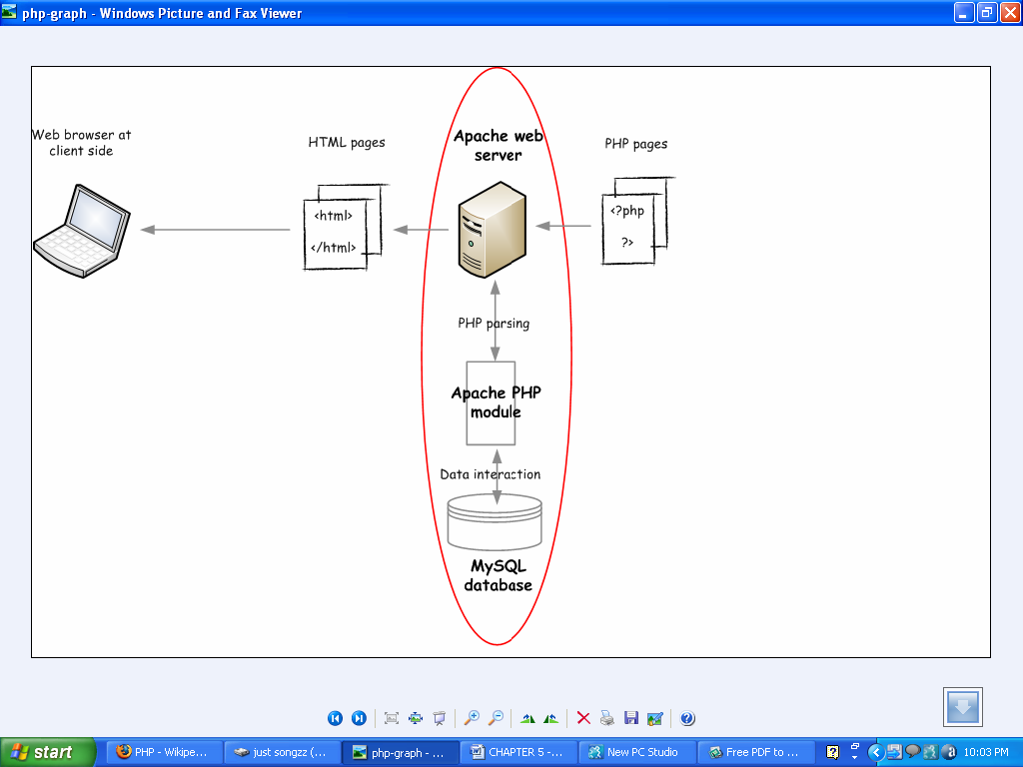

Working of PHP

When a client requests web page containing PHP code from the server, then the requested PHP pages are parsed under PHP environment and interaction with database is made if required.

After server side processing, the resulting HTML pages are passed to client and displayed on the browser.

In this way the working of php is complete.

**Connecting PHP Application to MySQL Database**

1) Make a connection variable to the database:

$con= mysql_connect ("localhost","servername","password");

Here $con is a connection variable to database.

2) Select a database over that connection variable:

$db=mysql_select_db("databasename",$con);

3) Prepare a sql query to execute:

$qry= Select * from abc;

4) Run the sql query:

$result=mysql_query($qry);

5) Iterate over the result:

while($row = mysql_fetch_array($result))

{

//some logic

}

**2.4.2 Introduction to MySQL:**

**MySQL** is a relational database management system (RDBMS) that runs as a server providing multi-user access to a number of databases. MySQL is officially pronounced ("My S-Q-L"), but is often pronounced ("My Sequel"). It is named for original developer Michael Widenius's daughter My.

The MySQL development project has made its source code available under the terms of the GNU General Public License, as well as under a variety of proprietary agreements. MySQL is owned and sponsored by a single for-profit firm, the Swedish company MySQL AB, now owned by Sun Microsystems, a subsidiary of Oracle Corporation.

MySQL code uses C and C++. The SQL parser uses yacc and a home-brewed lexer, sql_lex.cc.

MySQL works on many different system platforms, including AIX, BSDi, FreeBSD, HP-UX, i5/OS, Linux, Mac OS X, NetBSD, Novell NetWare, OpenBSD, OpenSolaris, eComStation, OS/2 Warp, QNX, IRIX, Solaris, Symbian, SunOS, SCO OpenServer, SCO UnixWare, Sanos, Tru64 and Microsoft Windows. A port of MySQL to OpenVMS also exists.

All major programming languages with language-specific APIs include Libraries for accessing MySQL database. In addition, an ODBC interface called MyODBC allows additional programming languages that support the ODBC interface to communicate with a MySQL database, such as ASP or ColdFusion. The HTSQL - URL based query method also ships with MySQL adapter allowing direct interaction with MySQL database from any web client via structured URLs. The MySQL server and official libraries are mostly implemented in ANSI C/ANSI C++.

**2.4.3 Introduction to APACHE SERVER:**

In this project apache server is used to parse and execute PHP pages, beforedeploying websites on the server, the website should be tested at the developer side to get a feel of how the website will work on actual server.

Therefore apache server is like a local server on the developer side, apache server should be informed about the environment on which it should work.

In our project apache server is configured to work with PHP, in this way all the PHP pages are parsed and executed by the server.

When apache is installed on the system, then its services is controlled by apache service monitor

**2.4.4 CSS**

**Cascading Style Sheets**, fondly referred to as **CSS**, is a simple design language intended to simplify the process of making web pages presentable.

**CSS** is a MUST for students and working professionals to become a great Software Engineer specially when they are working in Web Development Domain. I will list down some of the key advantages of learning CSS:

* **Create Stunning Web site** - CSS handles the look and feel part of a web page. Using CSS, you can control the color of the text, the style of fonts, the spacing between paragraphs, how columns are sized and laid out, what background images or colors are used, layout designs, variations in display for different devices and screen sizes as well as a variety of other effects.
* **Become a web designer** - If you want to start a career as a professional web designer, HTML and CSS designing is a must skill.
* **Control web** - CSS is easy to learn and understand but it provides powerful control over the presentation of an HTML document. Most commonly, CSS is combined with the markup languages HTML or XHTML.
* **Learn other languages** - Once you understands the basic of HTML and CSS then other related technologies like javascript, php, or angular are become easier to understand.

**2.4.5 JavaScript**

**Javascript** is a MUST for students and working professionals to become a great Software Engineer specially when they are working in Web Development Domain. I will list down some of the key advantages of learning Javascript:

* Javascript is the most popular **programming language** in the world and that makes it a programmer’s great choice. Once you learnt Javascript, it helps you developing great front-end as well as back-end softwares using different Javascript based frameworks like jQuery, Node.JS etc.
* Javascript is everywhere, it comes installed on every modern web browser and so to learn Javascript you really do not need any special environment setup. For example Chrome, Mozilla Firefox , Safari and every browser you know as of today, supports Javascript.
* Javascript helps you create really beautiful and crazy fast websites. You can develop your website with a console like look and feel and give your users the best Graphical User Experience.
* JavaScript usage has now extended to mobile app development, desktop app development, and game development. This opens many opportunities for you as Javascript Programmer.
* Due to high demand, there is tons of job growth and high pay for those who know JavaScript. You can navigate over to different job sites to see what having JavaScript skills looks like in the job market.
* Great thing about Javascript is that you will find tons of frameworks and Libraries already developed which can be used directly in your software development to reduce your time to market.

**2.4.6 Bootstrap**

Bootstrap is the popular HTML, CSS and JavaScript framework for developing a responsive and mobile friendly website. It uses HTML, CSS and Javascript. Bootstrap Framework using which you can create web projects with ease.

* **Mobile first approach** − Bootstrap 3, framework consists of Mobile first styles throughout the entire library instead them of in separate files.
* **Browser Support** − It is supported by all popular browsers.
* **Easy to get started** − With just the knowledge of HTML and CSS anyone can get started with Bootstrap. Also the Bootstrap official site has a good documentation.
* **Responsive design** − Bootstrap's responsive CSS adjusts to Desktops, Tablets and Mobiles. More about the responsive design is in the chapter [Bootstrap Responsive Design.](https://www.tutorialspoint.com/bootstrap/bootstrap_responsive_utilities.htm)
* Provides a clean and uniform solution for building an interface for developers.
* It contains beautiful and functional built-in components which are easy to customize.
* It also provides web based customization.
* And best of all it is an open source.

**Back End**: php MySql

MySQL is a relational database system that is used to store information. MySQL can store many types of data from something as tiny as a single character to as large as complete files or graphics. Although it can be accessed by most programming languages, it is often coupled with PHP because they work together with ease.

Information stored in a MySQL database hosted on a web server can be accessed from anywhere in the world with a computer. This makes it a good way to store information that needs the ability to change over time, but also needs to be accessed over the net. Some examples that can utilize MySQL are a web message board or a customer's shipping status.

**2.5 HARDWARE COMPONENTS:**

Processer : Platinum –III

RAM : 1 GB

Hard Disk : 5 GB

Monitor Internet Connection.

**2.6 JUSTIFICATION OF SELECTION OF TECHNOLOGY:**

We implement this system for better user experience. This system is very easy to access. Also, to establish real time communication, using modern and updated technology. So, user can see the update without reload or refresh. This system will compatible with user device such as PC, laptop, tab and smart phones. So, user can easily access the system anytime anywhere. This system is very simple and user-friendly so, any user can use this system easily

**Chapter 3**

**System Design**

## **CHAPTER 3 SYSTEM DESIGN**

### **3.1 MODULE DIVISION:-**

The system comprises of 2 major modules with their sub-modules as follows:

#### **Admin**

* Login
* Add/ View/Update/Delete Brands
* Add/ View/Update/Delete Vehicles
* Manage Booking
* Manage Testimonials
* Manage Contacts Us Query
* Manage Registration Users
* Manage Static Pages
* Update Contact Info
* Manage Subscribers
* Change Admin Password

#### **User**

* Login/Register
* View Car Listing
* Book Car
* View Booking
* Post a Testimonial
* Manage Profile
* Update Password
* Logout

**3.2 Data Dictionary:**

A data dictionary is a collection of descriptions of the data objects or items in a data model for the benefit of programmers and others who need to refer to them. Often a data dictionary is a centralized [metadata repository](https://searchoracle.techtarget.com/definition/metabase).

# **Concepts & terms - datasets, tables, data elements**

## **3.2.1 Datasets**

` In Reportnet and DD's context a dataset is a collection of tables containing the reported data. Often the "tables" will actually recede to a single table only. In a way DD datasets are stand-alone databases. Usually they come as MS Access databases or MS Excel files. They are subject to certain data flows and obliged to be reported by Reportnet players according to legislation. In many cases a dataset corresponds to a dataflow. For example there is the CDDA dataset defined in DD, which contains the information about reported data within that same-named data flow

## **3.2.2 Tables**

A table in DD's context is a table in dataset. Columns in a table stand for data elements, rows stand for their values.

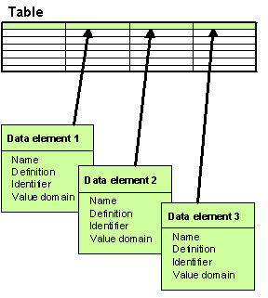

## **3.2.3 Data elements**

A data element in Data Dictionary's context is a column in a table. The figure above provides a visual representation of what a table and its elements (columns) are.  
On the highest level there are two classes of data elements in DD:

* **non-common elements** belong into a certain single table and they cannot be used in any other tables. They are defined within that certain table and they do not have a life outside of that table.
* **common elements** do not belong into a certain single table. They can be used in many tables, i.e. they can be part of many tables. You could also call them harmonised elements. They are potential candidates to be used in many datasets and tables and thus have been harmonised to avoid repetitions. A perfect example of a common element is for example CountryCode. It is obvious that CountryCode is probably needed in all datasets and many tables.

**3.3 Entity Relationship Diagrams (ERDs)**

An entity-relationship model, a graphical representation of entities & their relationships to each other, typically used in computing in regard to the organization of data-an object or concept about which data is stored. A relationship is how the data is shared between entities. There are three types of relationship between entities

Entity Relationship Diagrams (ERDs) illustrate the logical structure of databases:

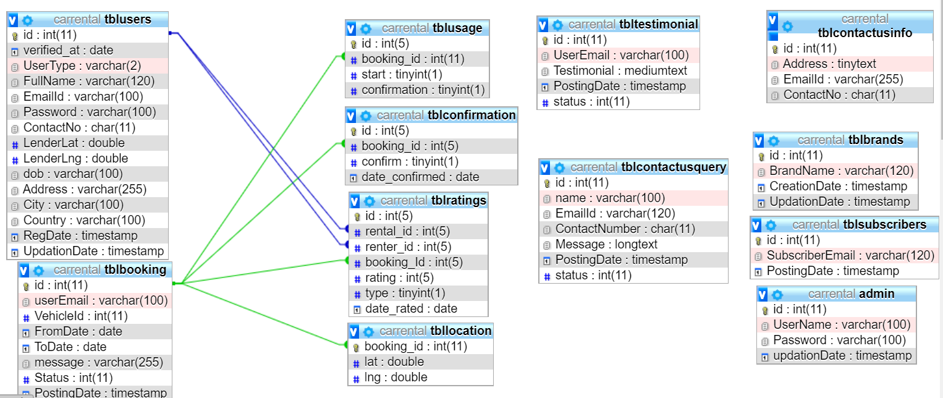

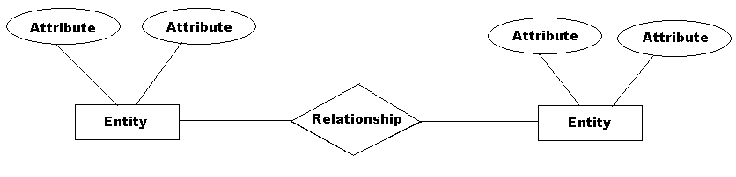

**Entity Relationship Diagram Notation:**

1. Entity:

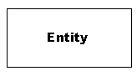

An entity is an object or concept about which you want to store information.

2. Weak Entity:

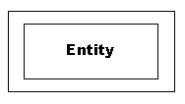

Attributes are the properties or characteristics of an entity.

3. Key Attribute:

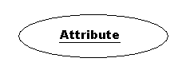

A key attribute is the unique, distinguishing characteristic of the entity. For example, an employee’s social security number might be the employee’s key attribute.

4. Multivalued Attribute:

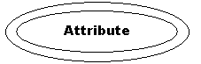

A multivalued attribute can have more than one value. For example, an employee entity can have multiple skill values.

5. Derived Attribute:

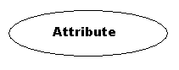

A derived attribute is based on another attribute. For example, an employee’s monthly salary is based on the employee’s annual salary.

6. Relationships:

**Relationship**

Relationships illustrate how two entities share information in the database structure.

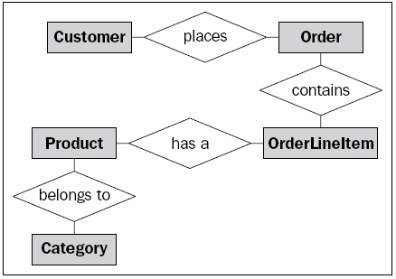

Entity relationship diagram displays the relationships of entity set stored in a database. In other words, we can say that ER diagrams help you to explain the logical structure of databases. At first look, an ER diagram looks very similar to the flowchart. However, ER Diagram includes many specialized symbols, and its meanings make this model unique.

**3.4) UML Diagrams**

**3.4.1 Use Case Diagram:-**

A use case diagram is a dynamic or behavior diagram in [UML](https://www.smartdraw.com/uml-diagram/). Use case diagrams model the functionality of a system using actors and use cases. Use cases are a set of actions, services, and functions that the system needs to perform. In this context, a "system" is something being developed or operated, such as a web site. The "actors" are people or entities operating under defined roles within the system.

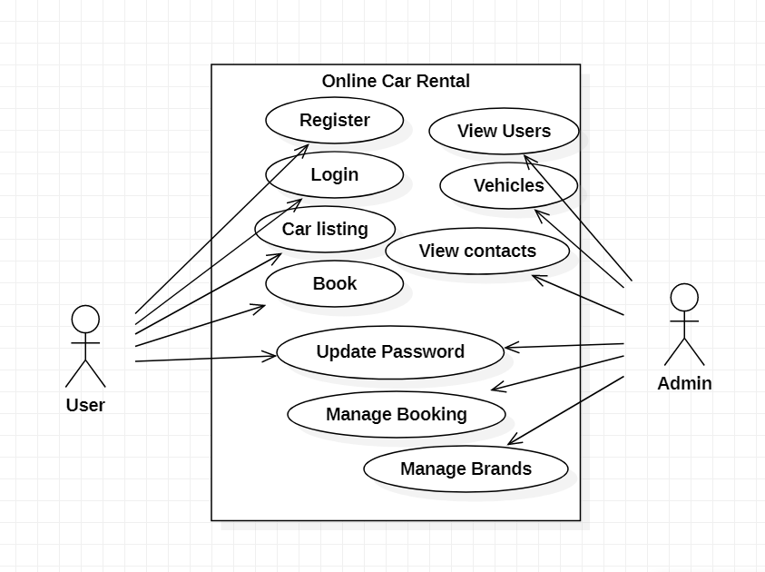

**Use Case Daigram**

## **Basic Use Case Diagram Symbols and Notations**

**System**  
Draw your system's boundaries using a rectangle that contains use cases. Place actors outside the system's boundaries.

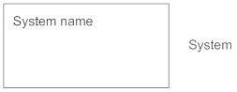

**Use Case**  
Draw use cases using ovals. Label the ovals with verbs that represent the system's functions.

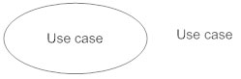

**Actors**  
Actors are the users of a system. When one system is the actor of another system, label the actor system with the actor stereotype.

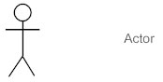

**Relationships**  
Illustrate relationships between an actor and a use case with a simple line. For relationships among use cases, use arrows labeled either "uses" or "extends." A "uses" relationship indicates that one use case is needed by another in order to perform a task. An "extends" relationship indicates alternative options under a certain use case.

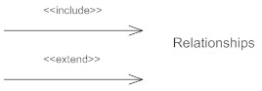

**3.4.2 DFD Diagram:-**

Data flow diagrams are used to graphically represent the flow of data in a business information system. DFD describes the processes that are involved in a system to transfer data from the input to the file storage and reports generation.

Data flow diagrams can be divided into logical and physical. The logical data flow diagram describes flow of data through a system to perform certain functionality of a business. The physical data flow diagram describes the implementation of the logical data flow.

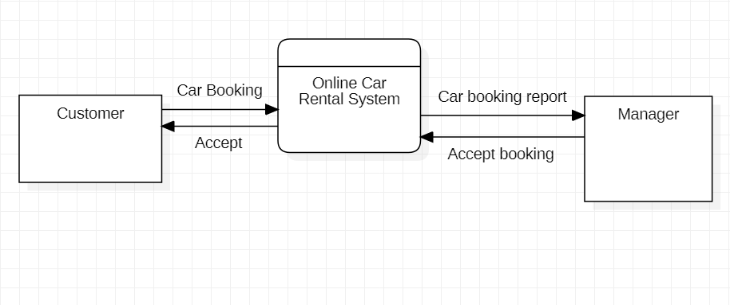

Data Flow Diagram

Above Data Flow Diagram, explains the overall structure of the system. It shows how and what types of services the client chooses and the amount of admin interaction in it.

Visually, the biggest difference between the two ways of drawing data flow diagrams is how processes look

**Process Notations.** A process transforms incoming data flow into outgoing data flow.

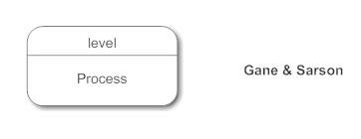

**Datastore Notations.** Datastores are repositories of data in the system. They are sometimes also referred to as files.

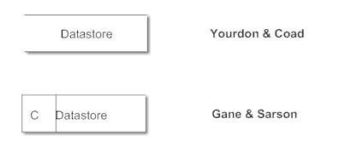

**Dataflow Notations.** Data flows are pipelines through which packets of information flow. Label the arrows with the name of the data that moves through it.

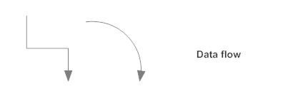

**External Entity Notations.** External entities are objects outside the system, with which the system communicates. External entities are sources and destinations of the system's inputs and outputs.

**Graphical representation of data processes**

* Focuses on the business and how the business operates
* Business events that take place and the data required and produced by each event not concerned with how the system will be constructed

**Advantages of using a DFD:**

* Better communication with users
* More stable systems
* Better understanding of the business by analysts
* Easy to maintain

**2.4.3 Sequence Diagram**

Sequence diagrams describe interactions among classes in terms of an exchange of messages over time. They're also called event diagrams. A sequence diagram is a good way to visualize and validate various runtime scenarios. These can help to predict how a system will behave and to discover responsibilities a class may need to have in the process of modeling a new system.

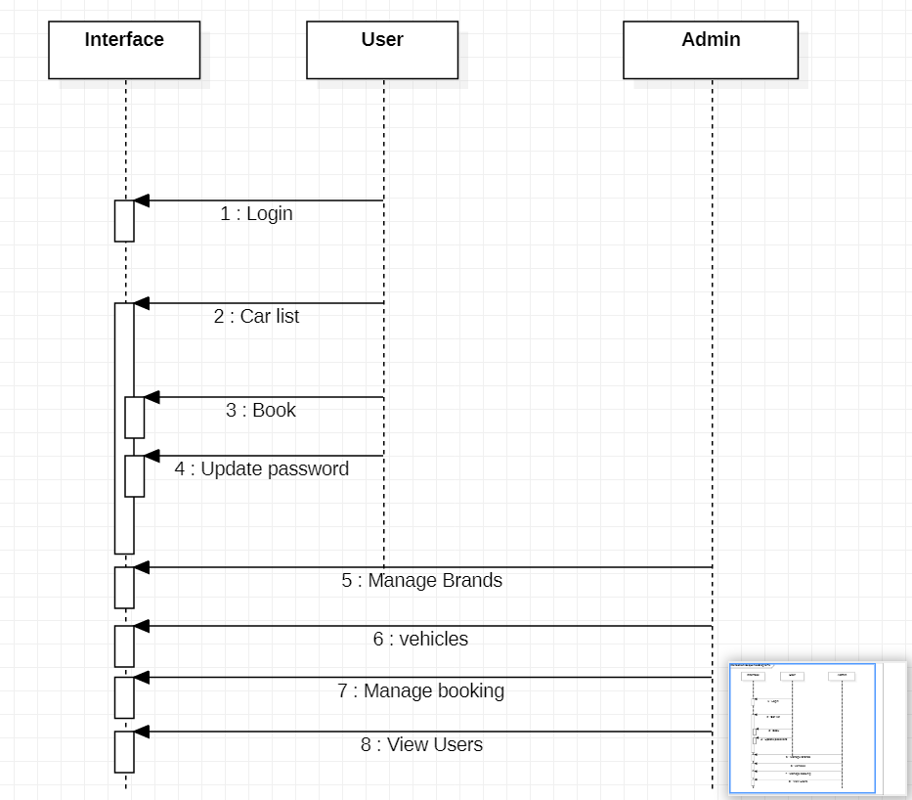

**Sequence Diagram**

## **Basic Sequence Diagram Notations**

**Class Roles or Participants**  
Class roles describe the way an object will behave in context. Use the UML object symbol to illustrate class roles, but don't list object attributes.

Object symbol - Sequence diagram

**Activation or Execution Occurrence**  
Activation boxes represent the time an object needs to complete a task. When an object is busy executing a process or waiting for a reply message, use a thin gray rectangle placed vertically on its lifeline.

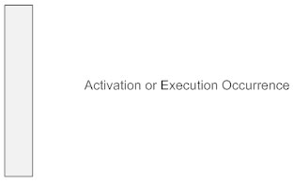

**Messages**  
Messages are arrows that represent communication between objects. Use half-arrowed lines to represent asynchronous messages. Asynchronous messages are sent from an object that will not wait for a response from the receiver before continuing its tasks. For message types, see below.

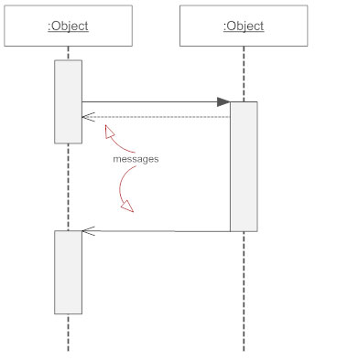

**Lifelines**  
Lifelines are vertical dashed lines that indicate the object's presence over time.

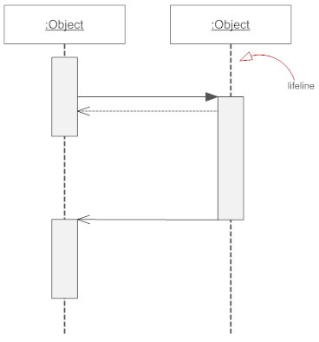

**Destroying Objects**  
Objects can be terminated early using an arrow labeled "<< destroy >>" that points to an X. This object is removed from memory. When that object's lifeline ends, you can place an X at the end of its lifeline to denote a destruction occurrence.

**Loops**  
A repetition or loop within a sequence diagram is depicted as a rectangle. Place the condition for exiting the loop at the bottom left corner in square brackets [ ].

## **Types of Messages in Sequence Diagrams**

**Synchronous Message**  
A synchronous message requires a response before the interaction can continue. It's usually drawn using a line with a solid arrowhead pointing from one object to another.

Synchronous message - Sequence diagram

**Asynchronous Message**  
Asynchronous messages don't need a reply for interaction to continue. Like synchronous messages, they are drawn with an arrow connecting two lifelines; however, the arrowhead is usually open and there's no return message depicted.

Simple messageAsyncrhonous message

**Reply or Return Message**  
A reply message is drawn with a dotted line and an open arrowhead pointing back to the original lifeline.

Reply messages

**Self Message**  
A message an object sends to itself, usually shown as a U shaped arrow pointing back to itself.

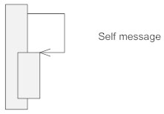

**Create Message**  
This is a message that creates a new object. Similar to a return message, it's depicted with a dashed line and an open arrowhead that points to the rectangle representing the object created.

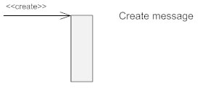

**Delete Message**  
This is a message that destroys an object. It can be shown by an arrow with an x at the end.

Delete message

**Found Message**  
A message sent from an unknown recipient, shown by an arrow from an endpoint to a lifeline.

Found message

**Lost Message**  
A message sent to an unknown recipient. It's shown by an arrow going from a lifeline to an endpoint, a filled circle or an x.

Lost message

**2.4.4 Activity Diagram**

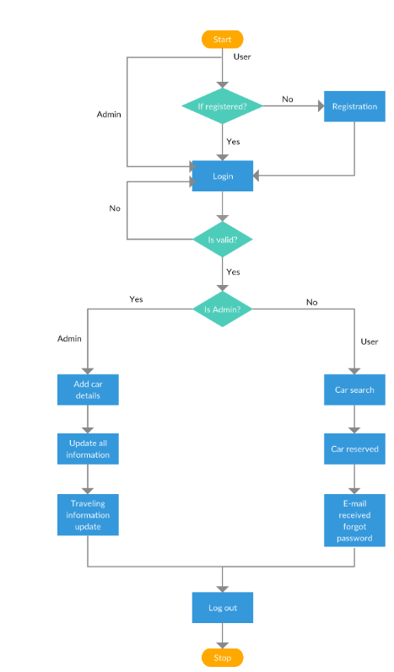

An activity diagram visually presents a series of actions or flow of control in a system similar to a [flowchart](https://www.smartdraw.com/flowchart/) or a [data flow diagram](https://www.smartdraw.com/data-flow-diagram/). Activity diagrams are often used in business process modeling. They can also describe the steps in a [use case diagram](https://www.smartdraw.com/use-case-diagram/). Activities modeled can be sequential and concurrent. In both cases an activity diagram will have a beginning (an initial state) and an end (a final state).

## **Basic Activity Diagram Notations and Symbols**

##### **Initial State or Start Point**

A small filled circle followed by an arrow represents the initial action state or the start point for any activity diagram. For activity diagram using swimlanes, make sure the start point is placed in the top left corner of the first column.

Start point symbol - Activity diagram

##### **Activity or Action State**

An action state represents the non-interruptible action of objects. You can draw an action state in SmartDraw using a rectangle with rounded corners.

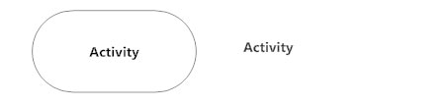

##### **Action Flow**

Action flows, also called edges and paths, illustrate the transitions from one action state to another. They are usually drawn with an arrowed line.

Action flow - Activity diagram

##### **Object Flow**

Object flow refers to the creation and modification of objects by activities. An object flow arrow from an action to an object means that the action creates or influences the object. An object flow arrow from an object to an action indicates that the action state uses the object.

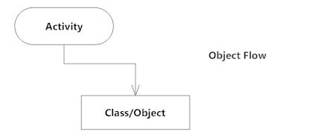

##### **Decisions and Branching**

A diamond represents a decision with alternate paths. When an activity requires a decision prior to moving on to the next activity, add a diamond between the two activities. The outgoing alternates should be labeled with a condition or guard expression. You can also label one of the paths "else."

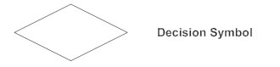

##### **Guards**

In UML, guards are a statement written next to a decision diamond that must be true before moving next to the next activity. These are not essential, but are useful when a specific answer, such as "Yes, three labels are printed," is needed before moving forward.

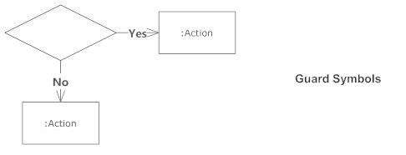

##### **Synchronization**

A fork node is used to split a single incoming flow into multiple concurrent flows. It is represented as a straight, slightly thicker line in an activity diagram.

A join node joins multiple concurrent flows back into a single outgoing flow.

A fork and join mode used together are often referred to as synchronization.

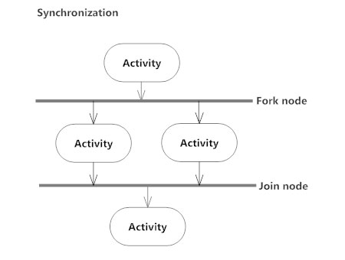

##### **Time Event**

This refers to an event that stops the flow for a time; an hourglass depicts it.

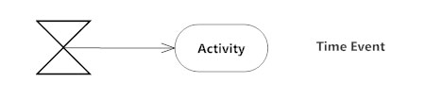

##### **Merge Event**

A merge event brings together multiple flows that are not concurrent.

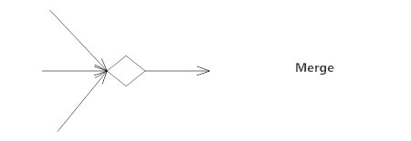

##### **Sent and Received Signals**

Signals represent how activities can be modified from outside the system. They usually appear in pairs of sent and received signals, because the state can't change until a response is received, much like synchronous messages in a [sequence diagram](https://www.smartdraw.com/sequence-diagram/). For example, an authorization of payment is needed before an order can be completed.

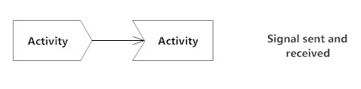

##### **Interrupting Edge**

An event, such as a cancellation, that interrupts the flow denoted with a lightning bolt.

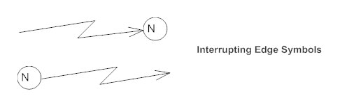

##### **Swimlanes**

Swimlanes group related activities into one column.

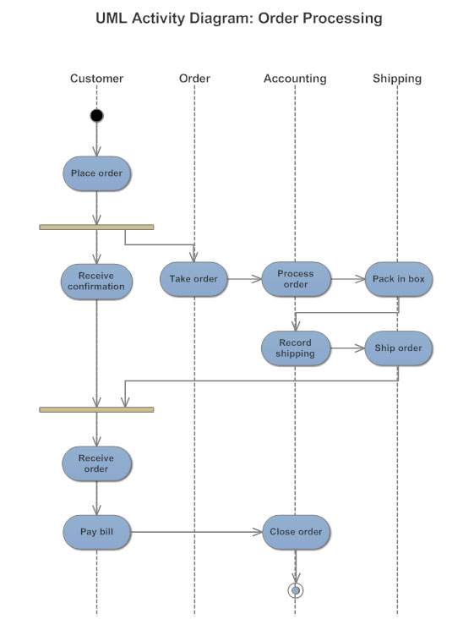

##### **Final State or End Point**

An arrow pointing to a filled circle nested inside another circle represents the final action state.

End point symbol - Activity diagram

**2.4.5 Gantt Chart**

A **Gantt chart** is a type of [bar chart](https://en.wikipedia.org/wiki/Bar_chart) that illustrates a [project schedule](https://en.wikipedia.org/wiki/Schedule_(project_management)), named after its inventor, [Henry Gantt](https://en.wikipedia.org/wiki/Henry_Gantt) (1861–1919), who designed such a chart around the years 1910–1915. Modern Gantt charts also show the [dependency](https://en.wikipedia.org/wiki/Dependency_(project_management)) relationships between activities and the current schedule status.

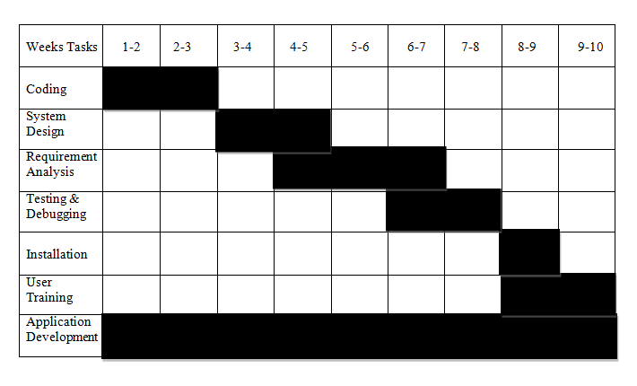

A Gantt chart is a type of bar char that illustrates a project schedule.This chart lists the tasks to be performed on the vertical axis, and time intervals on the horizontal axis. The width of the horizontal bars in the graph shows the duration of each activity. Gantt charts illustrate the start and finish dates of the terminal elements and summary elements of a [project](https://en.wikipedia.org/wiki/Project). Terminal elements and summary elements constitute the [work breakdown structure](https://en.wikipedia.org/wiki/Work_breakdown_structure) of the project. Modern Gantt charts also show the [dependency](https://en.wikipedia.org/wiki/Dependency_(project_management)) (i.e., precedence network) relationships between activities. Gantt charts can be used to show current schedule status using percent-complete shadings and a vertical "TODAY" line.

Gantt charts are sometimes equated with bar charts.

Gantt charts are usually created initially using an *early start time approach*, where each task is scheduled to start immediately when its prerequisites are complete. This method maximizes the [float time](https://en.wikipedia.org/wiki/Float_(project_management)) available for all tasks.

**3.5) Database Schema**

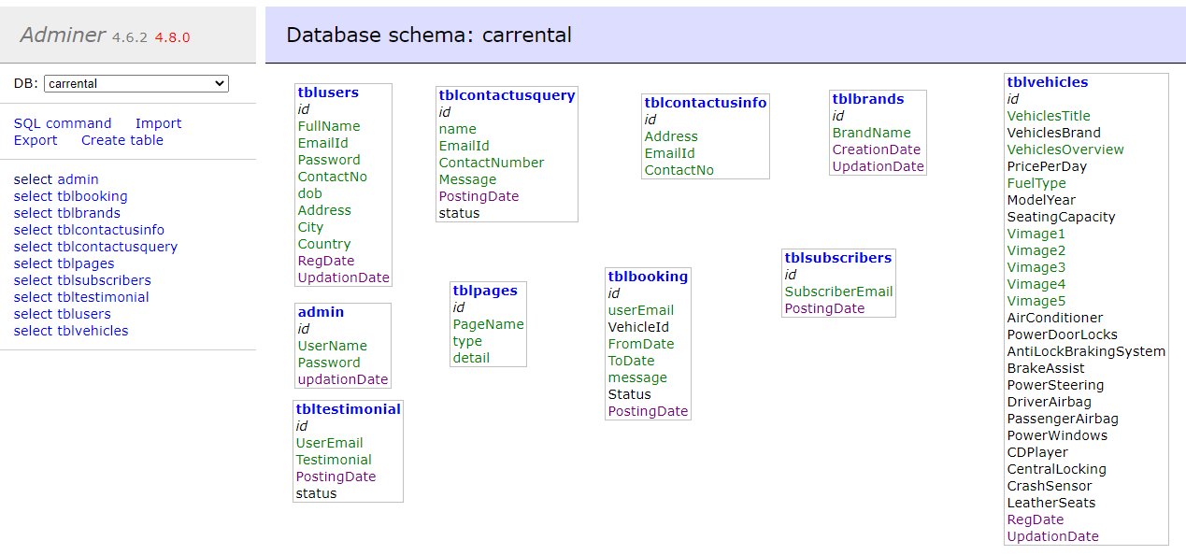

**3.5.1 Admin Table Structure**

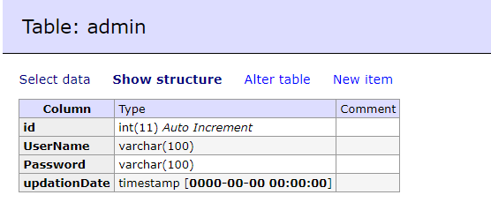

**3.5.2 Booking Table Structure**

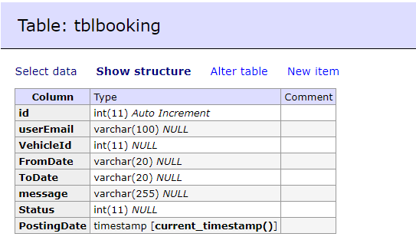

**3.5.3 Brand Table Structure**

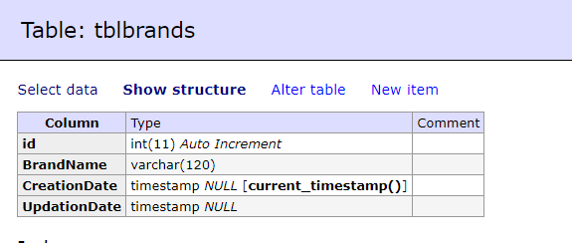

**3.5.4 Contact Us Info Table Structure**

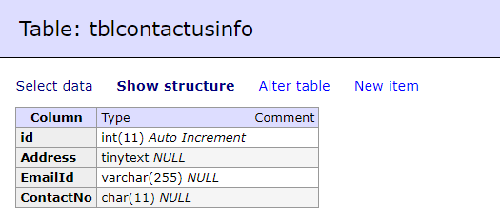

**3.5.5 Contact US Query Table Structure**

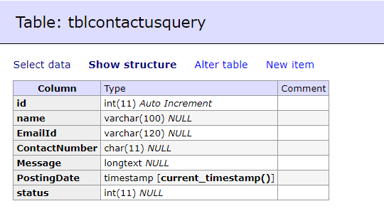

**3.5.6 Pages Table Structure**

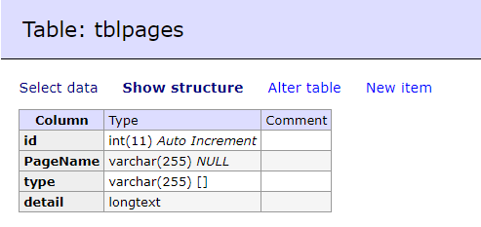

**3.5.7 Subcribers Table Structure**

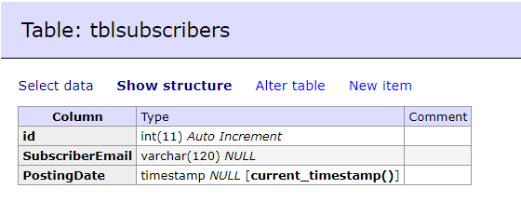

**3.5.8 Testumonial Table Structure**

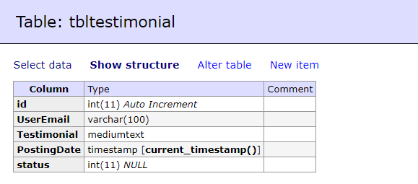

**3.5.9 Users Table Structure**

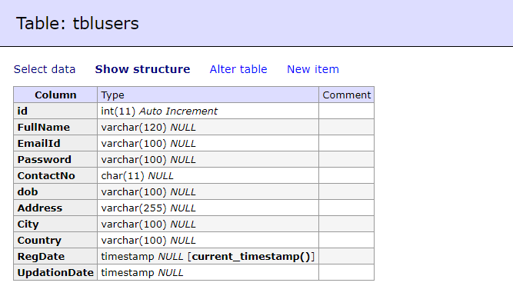

**3.5.10 Vehicle Table Structure**

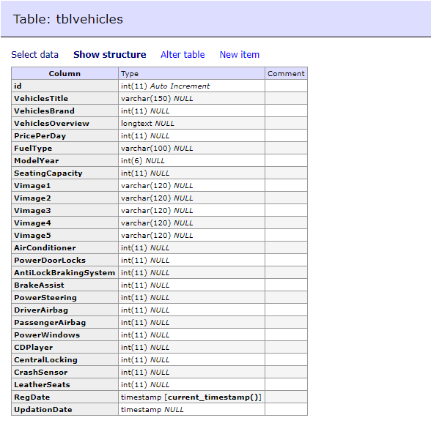

**Chapter 4**

**Implementation and Testing**

**Chapter 4: Implementation and Testing**

**4.1 Code**

**1] Home PAGE:**

<?php

session_start();

include('includes/config.php');

error_reporting(0);

?>

<!DOCTYPE HTML>

<html lang="en">

<head>

<meta http-equiv="Content-Type" content="text/html; charset=utf-8">

<meta http-equiv="X-UA-Compatible" content="IE=edge">

<meta name="viewport" content="width=device-width,initial-scale=1">

<meta name="keywords" content="">

<meta name="description" content="">

<title>UK Online Cab Rental</title>

<!--Bootstrap -->

<link rel="stylesheet" href="assets/css/bootstrap.min.css" type="text/css">

<link rel="stylesheet" href="assets/css/style.css" type="text/css">

<link rel="stylesheet" href="assets/css/owl.carousel.css" type="text/css">

<link rel="stylesheet" href="assets/css/owl.transitions.css" type="text/css">

<link href="assets/css/slick.css" rel="stylesheet">

<link href="assets/css/bootstrap-slider.min.css" rel="stylesheet">

<link href="assets/css/font-awesome.min.css" rel="stylesheet">

<link rel="stylesheet" id="switcher-css" type="text/css" href="assets/switcher/css/switcher.css" media="all" />

<link rel="alternate stylesheet" type="text/css" href="assets/switcher/css/red.css" title="red" media="all" data-default-color="true" />

<link rel="alternate stylesheet" type="text/css" href="assets/switcher/css/orange.css" title="orange" media="all" />

<link rel="alternate stylesheet" type="text/css" href="assets/switcher/css/blue.css" title="blue" media="all" />

<link rel="alternate stylesheet" type="text/css" href="assets/switcher/css/pink.css" title="pink" media="all" />

<link rel="alternate stylesheet" type="text/css" href="assets/switcher/css/green.css" title="green" media="all" />

<link rel="alternate stylesheet" type="text/css" href="assets/switcher/css/purple.css" title="purple" media="all" />

<link rel="apple-touch-icon-precomposed" sizes="144x144" href="assets/images/favicon-icon/apple-touch-icon-144-precomposed.png">

<link rel="apple-touch-icon-precomposed" sizes="114x114" href="assets/images/favicon-icon/apple-touch-icon-114-precomposed.html">

<link rel="apple-touch-icon-precomposed" sizes="72x72" href="assets/images/favicon-icon/apple-touch-icon-72-precomposed.png">

<link rel="apple-touch-icon-precomposed" href="assets/images/favicon-icon/apple-touch-icon-57-precomposed.png">

<link rel="shortcut icon" href="assets/images/favicon-icon/favicon.png">

<link href="https://fonts.googleapis.com/css?family=Lato:300,400,700,900" rel="stylesheet">

</head>

<body>

<!-- Start Switcher -->

<?php include('includes/colorswitcher.php');?>

<!-- /Switcher -->

<!--Header-->

<?php include('includes/header.php');?>

<!-- /Header -->

<!-- Banners -->

<section id="banner" class="banner-section">

<div class="container">

<div class="div_zindex">

<div class="row">

<div class="col-md-5 col-md-push-7">

<div class="banner_content">

<h1>Find the right car for you.</h1>

<p>We have more than a thousand cars for you to choose. </p>

<a href="#" class="btn">Read More <span class="angle_arrow"><i class="fa fa-angle-right" aria-hidden="true"></i></span></a> </div>

</div>

</div>

</div>

</div>

</section>

<!-- /Banners -->

<!-- Resent Cat-->

<section class="section-padding gray-bg">

<div class="container">

<div class="section-header text-center">

<h2>Find the Best <span>CarForYou</span></h2>

<p>We offer a varied fleet of cars, ranging from the compact Toyota Yaris to the 8-seater VW Multivan. All our vehicles have air conditioning, power steering, electric windows. All our vehicles are bought and maintained at official dealerships only. Automatic transmission cars are available in every booking class. We pride ourselves on personalized service, great cars and excellent rates.</p>

</div>

<div class="row">

<!-- Nav tabs -->

<div class="recent-tab">

<ul class="nav nav-tabs" role="tablist">

<li role="presentation" class="active"><a href="#resentnewcar" role="tab" data-toggle="tab">New Car</a></li>

</ul>

</div>

<!-- Recently Listed New Cars -->

<div class="tab-content">

<div role="tabpanel" class="tab-pane active" id="resentnewcar">

<?php $sql = "SELECT tblvehicles.VehiclesTitle,tblbrands.BrandName,tblvehicles.PricePerDay,tblvehicles.FuelType,tblvehicles.ModelYear,tblvehicles.id,tblvehicles.SeatingCapacity,tblvehicles.VehiclesOverview,tblvehicles.Vimage1 from tblvehicles join tblbrands on tblbrands.id=tblvehicles.VehiclesBrand";

$query = $dbh -> prepare($sql);

$query->execute();

$results=$query->fetchAll(PDO::FETCH_OBJ);

$cnt=1;

if($query->rowCount() > 0)

{

foreach($results as $result)

{

?>

<div class="col-list-3">

<div class="recent-car-list">

<div class="car-info-box"> <a href="vehical-details.php?vhid=<?php echo htmlentities($result->id);?>"><img src="admin/img/vehicleimages/<?php echo htmlentities($result->Vimage1);?>" class="img-responsive" alt="image"></a>

<ul>

<li><i class="fa fa-car" aria-hidden="true"></i><?php echo htmlentities($result->FuelType);?></li>

<li><i class="fa fa-calendar" aria-hidden="true"></i><?php echo htmlentities($result->ModelYear);?> Model</li>

<li><i class="fa fa-user" aria-hidden="true"></i><?php echo htmlentities($result->SeatingCapacity);?> seats</li>

</ul>

</div>

<div class="car-title-m">

<h6><a href="vehical-details.php?vhid=<?php echo htmlentities($result->id);?>"><?php echo htmlentities($result->BrandName);?> , <?php echo htmlentities($result->VehiclesTitle);?></a></h6>

<span class="price">₹<?php echo htmlentities($result->PricePerDay);?> /Day</span>

</div>

<div class="inventory_info_m">

<p><?php echo substr($result->VehiclesOverview,0,70);?></p>

</div>

</div>

</div>

<?php }}?>

</div>

</div>

</div>

</section>

<!-- /Resent Cat -->

<!-- Fun Facts-->

<section class="fun-facts-section">

<div class="container div_zindex">

<div class="row">

<div class="col-lg-3 col-xs-6 col-sm-3">

<div class="fun-facts-m">

<div class="cell">

<h2><i class="fa fa-calendar" aria-hidden="true"></i>40+</h2>

<p>Years In Business</p>

</div>

</div>

</div>

<div class="col-lg-3 col-xs-6 col-sm-3">

<div class="fun-facts-m">

<div class="cell">

<h2><i class="fa fa-car" aria-hidden="true"></i>1200+</h2>

<p>New Cars For Sale</p>

</div>

</div>

</div>

<div class="col-lg-3 col-xs-6 col-sm-3">

<div class="fun-facts-m">

<div class="cell">

<h2><i class="fa fa-car" aria-hidden="true"></i>1000+</h2>

<p>Used Cars For Sale</p>

</div>

</div>

</div>

<div class="col-lg-3 col-xs-6 col-sm-3">

<div class="fun-facts-m">

<div class="cell">

<h2><i class="fa fa-user-circle-o" aria-hidden="true"></i>600+</h2>

<p>Satisfied Customers</p>

</div>

</div>

</div>

</div>

</div>

<!-- Dark Overlay-->

<div class="dark-overlay"></div>

</section>

<!-- /Fun Facts-->

<!--Testimonial -->

<section class="section-padding testimonial-section parallex-bg">

<div class="container div_zindex">

<div class="section-header white-text text-center">

<h2>Our Satisfied <span>Customers</span></h2>

</div>

<div class="row">

<div id="testimonial-slider">

<?php

$tid=1;

$sql = "SELECT tbltestimonial.Testimonial,tblusers.FullName from tbltestimonial join tblusers on tbltestimonial.UserEmail=tblusers.EmailId where tbltestimonial.status=:tid";

$query = $dbh -> prepare($sql);

$query->bindParam(':tid',$tid, PDO::PARAM_STR);

$query->execute();

$results=$query->fetchAll(PDO::FETCH_OBJ);

$cnt=1;

if($query->rowCount() > 0)

{

foreach($results as $result)

{ ?>

<div class="testimonial-m">

<div class="testimonial-img"> <img src="assets/images/cat-profile.png" alt="" /> </div>

<div class="testimonial-content">

<div class="testimonial-heading">

<h5><?php echo htmlentities($result->FullName);?></h5>

<p><?php echo htmlentities($result->Testimonial);?></p>

</div>

</div>

</div>

<?php }} ?>

</div>

</div>

</div>

<!-- Dark Overlay-->

<div class="dark-overlay"></div>

</section>

<!-- /Testimonial-->

<!--Footer -->

<?php include('includes/footer.php');?>

<!-- /Footer-->

<!--Back to top-->

<div id="back-top" class="back-top"> <a href="#top"><i class="fa fa-angle-up" aria-hidden="true"></i> </a> </div>

<!--/Back to top-->

<!--Login-Form -->

<?php include('includes/login.php');?>

<!--/Login-Form -->

<!--Register-Form -->

<?php include('includes/registration.php');?>

<!--/Register-Form -->

<!--Forgot-password-Form -->

<?php include('includes/forgotpassword.php');?>

<!--/Forgot-password-Form -->

<!-- Scripts -->

<script src="assets/js/jquery.min.js"></script>

<script src="assets/js/bootstrap.min.js"></script>

<script src="assets/js/interface.js"></script>

<!--Switcher-->

<script src="assets/switcher/js/switcher.js"></script>

<!--bootstrap-slider-JS-->

<script src="assets/js/bootstrap-slider.min.js"></script>

<!--Slider-JS-->

<script src="assets/js/slick.min.js"></script>

<script src="assets/js/owl.carousel.min.js"></script>

</body>

</html>

**2] Car Listing:**

<?php

session_start();

include('includes/config.php');

error_reporting(0);

?>

<!DOCTYPE HTML>

<html lang="en">

<head>

<meta http-equiv="Content-Type" content="text/html; charset=utf-8">

<meta http-equiv="X-UA-Compatible" content="IE=edge">

<meta name="viewport" content="width=device-width,initial-scale=1">

<meta name="keywords" content="">

<meta name="description" content="">

<title>Car Rental Portal | Car Listing</title>

<!--Bootstrap -->

<link rel="stylesheet" href="assets/css/bootstrap.min.css" type="text/css">

<!--Custome Style -->

<link rel="stylesheet" href="assets/css/style.css" type="text/css">

<!--OWL Carousel slider-->

<link rel="stylesheet" href="assets/css/owl.carousel.css" type="text/css">

<link rel="stylesheet" href="assets/css/owl.transitions.css" type="text/css">

<!--slick-slider -->

<link href="assets/css/slick.css" rel="stylesheet">

<!--bootstrap-slider -->

<link href="assets/css/bootstrap-slider.min.css" rel="stylesheet">

<!--FontAwesome Font Style -->

<link href="assets/css/font-awesome.min.css" rel="stylesheet">

<!-- SWITCHER -->

<link rel="stylesheet" id="switcher-css" type="text/css" href="assets/switcher/css/switcher.css" media="all" />

<link rel="alternate stylesheet" type="text/css" href="assets/switcher/css/red.css" title="red" media="all" data-default-color="true" />

<link rel="alternate stylesheet" type="text/css" href="assets/switcher/css/orange.css" title="orange" media="all" />

<link rel="alternate stylesheet" type="text/css" href="assets/switcher/css/blue.css" title="blue" media="all" />

<link rel="alternate stylesheet" type="text/css" href="assets/switcher/css/pink.css" title="pink" media="all" />

<link rel="alternate stylesheet" type="text/css" href="assets/switcher/css/green.css" title="green" media="all" />

<link rel="alternate stylesheet" type="text/css" href="assets/switcher/css/purple.css" title="purple" media="all" />

<!-- Fav and touch icons -->

<link rel="apple-touch-icon-precomposed" sizes="144x144" href="assets/images/favicon-icon/apple-touch-icon-144-precomposed.png">

<link rel="apple-touch-icon-precomposed" sizes="114x114" href="assets/images/favicon-icon/apple-touch-icon-114-precomposed.html">

<link rel="apple-touch-icon-precomposed" sizes="72x72" href="assets/images/favicon-icon/apple-touch-icon-72-precomposed.png">

<link rel="apple-touch-icon-precomposed" href="assets/images/favicon-icon/apple-touch-icon-57-precomposed.png">

<link rel="shortcut icon" href="assets/images/favicon-icon/favicon.png">

<link href="https://fonts.googleapis.com/css?family=Lato:300,400,700,900" rel="stylesheet">

</head>

<body>

<!-- Start Switcher -->

<?php include('includes/colorswitcher.php');?>

<!-- /Switcher -->

<!--Header-->

<?php include('includes/header.php');?>

<!-- /Header -->

<!--Page Header-->

<section class="page-header listing_page">

<div class="container">

<div class="page-header_wrap">

<div class="page-heading">

<h1>Car Listing</h1>

</div>

<ul class="coustom-breadcrumb">

<li><a href="#">Home</a></li>

<li>Car Listing</li>

</ul>

</div>

</div>

<!-- Dark Overlay-->

<div class="dark-overlay"></div>

</section>

<!-- /Page Header-->

<!--Listing-->

<section class="listing-page">

<div class="container">

<div class="row">

<div class="col-md-9 col-md-push-3">

<div class="result-sorting-wrapper">

<div class="sorting-count">

<?php

//Query for Listing count

$sql = "SELECT id from tblvehicles";

$query = $dbh -> prepare($sql);

$query->bindParam(':vhid',$vhid, PDO::PARAM_STR);

$query->execute();

$results=$query->fetchAll(PDO::FETCH_OBJ);

$cnt=$query->rowCount();

?>

<p><span><?php echo htmlentities($cnt);?> Listings</span></p>

</div>

</div>

<?php $sql = "SELECT tblvehicles.*,tblbrands.BrandName,tblbrands.id as bid from tblvehicles join tblbrands on tblbrands.id=tblvehicles.VehiclesBrand";

$query = $dbh -> prepare($sql);

$query->execute();

$results=$query->fetchAll(PDO::FETCH_OBJ);

$cnt=1;

if($query->rowCount() > 0)

{

foreach($results as $result)

{ ?>

<div class="product-listing-m gray-bg">

<div class="product-listing-img"><img src="admin/img/vehicleimages/<?php echo htmlentities($result->Vimage1);?>" class="img-responsive" alt="Image" /> </a>

</div>

<div class="product-listing-content">

<h5><a href="vehical-details.php?vhid=<?php echo htmlentities($result->id);?>"><?php echo htmlentities($result->BrandName);?> , <?php echo htmlentities($result->VehiclesTitle);?></a></h5>

<p class="list-price">₹<?php echo htmlentities($result->PricePerDay);?> Per Day</p>

<ul>

<li><i class="fa fa-user" aria-hidden="true"></i><?php echo htmlentities($result->SeatingCapacity);?> seats</li>

<li><i class="fa fa-calendar" aria-hidden="true"></i><?php echo htmlentities($result->ModelYear);?> model</li>

<li><i class="fa fa-car" aria-hidden="true"></i><?php echo htmlentities($result->FuelType);?></li>

</ul>

<a href="vehical-details.php?vhid=<?php echo htmlentities($result->id);?>" class="btn">View Details <span class="angle_arrow"><i class="fa fa-angle-right" aria-hidden="true"></i></span></a>

</div>

</div>

<?php }} ?>

</div>

<!--Side-Bar-->

<aside class="col-md-3 col-md-pull-9">

<div class="sidebar_widget">

<div class="widget_heading">

<h5><i class="fa fa-filter" aria-hidden="true"></i> Find Your Car </h5>

</div>

<div class="sidebar_filter">

<form action="search-carresult.php" method="post">

<div class="form-group select">

<select class="form-control" name="brand">

<option>Select Brand</option>

<?php $sql = "SELECT * from tblbrands ";

$query = $dbh -> prepare($sql);

$query->execute();

$results=$query->fetchAll(PDO::FETCH_OBJ);

$cnt=1;

if($query->rowCount() > 0)

{

foreach($results as $result)

{ ?>

<option value="<?php echo htmlentities($result->id);?>"><?php echo htmlentities($result->BrandName);?></option>

<?php }} ?>

</select>

</div>

<div class="form-group select">

<select class="form-control" name="fueltype">

<option>Select Fuel Type</option>

<option value="Petrol">Petrol</option>

<option value="Diesel">Diesel</option>

<option value="CNG">CNG</option>

</select>

</div>

<div class="form-group">

<button type="submit" class="btn btn-block"><i class="fa fa-search" aria-hidden="true"></i> Search Car</button>

</div>

</form>

</div>

</div>

<div class="sidebar_widget">

<div class="widget_heading">

<h5><i class="fa fa-car" aria-hidden="true"></i> Recently Listed Cars</h5>

</div>

<div class="recent_addedcars">

<ul>

<?php $sql = "SELECT tblvehicles.*,tblbrands.BrandName,tblbrands.id as bid from tblvehicles join tblbrands on tblbrands.id=tblvehicles.VehiclesBrand order by id desc limit 4";

$query = $dbh -> prepare($sql);

$query->execute();

$results=$query->fetchAll(PDO::FETCH_OBJ);

$cnt=1;

if($query->rowCount() > 0)

{

foreach($results as $result)

{ ?>

<li class="gray-bg">

<div class="recent_post_img"> <a href="vehical-details.php?vhid=<?php echo htmlentities($result->id);?>"><img src="admin/img/vehicleimages/<?php echo htmlentities($result->Vimage1);?>" alt="image"></a> </div>

<div class="recent_post_title"> <a href="vehical-details.php?vhid=<?php echo htmlentities($result->id);?>"><?php echo htmlentities($result->BrandName);?> , <?php echo htmlentities($result->VehiclesTitle);?></a>

<p class="widget_price">₹<?php echo htmlentities($result->PricePerDay);?> Per Day</p>

</div>

</li>

<?php }} ?>

</ul>

</div>

</div>

</aside>

<!--/Side-Bar-->

</div>

</div>

</section>

<!-- /Listing-->

<!--Footer -->

<?php include('includes/footer.php');?>

<!-- /Footer-->

<!--Back to top-->

<div id="back-top" class="back-top"> <a href="#top"><i class="fa fa-angle-up" aria-hidden="true"></i> </a> </div>

<!--/Back to top-->

<!--Login-Form -->

<?php include('includes/login.php');?>

<!--/Login-Form -->

<!--Register-Form -->

<?php include('includes/registration.php');?>

<!--/Register-Form -->

<!--Forgot-password-Form -->

<?php include('includes/forgotpassword.php');?>

<!-- Scripts -->

<script src="assets/js/jquery.min.js"></script>

<script src="assets/js/bootstrap.min.js"></script>

<script src="assets/js/interface.js"></script>

<!--Switcher-->

<script src="assets/switcher/js/switcher.js"></script>

<!--bootstrap-slider-JS-->

<script src="assets/js/bootstrap-slider.min.js"></script>

<!--Slider-JS-->

<script src="assets/js/slick.min.js"></script>

<script src="assets/js/owl.carousel.min.js"></script>

</body>

</html>

**3] Booking PAGE:**

<?php

session_start();

error_reporting(0);

include('includes/config.php');

if(strlen($_SESSION['login'])==0)

{

header('location:index.php');

}

else{

?><!DOCTYPE HTML>

<html lang="en">

<head>

<meta http-equiv="Content-Type" content="text/html; charset=utf-8">

<meta http-equiv="X-UA-Compatible" content="IE=edge">

<meta name="viewport" content="width=device-width,initial-scale=1">

<meta name="keywords" content="">

<meta name="description" content="">

<title>CarForYou - Responsive Car Dealer HTML5 Template</title>

<!--Bootstrap -->

<link rel="stylesheet" href="assets/css/bootstrap.min.css" type="text/css">

<!--Custome Style -->

<link rel="stylesheet" href="assets/css/style.css" type="text/css">

<!--OWL Carousel slider-->

<link rel="stylesheet" href="assets/css/owl.carousel.css" type="text/css">

<link rel="stylesheet" href="assets/css/owl.transitions.css" type="text/css">

<!--slick-slider -->

<link href="assets/css/slick.css" rel="stylesheet">

<!--bootstrap-slider -->

<link href="assets/css/bootstrap-slider.min.css" rel="stylesheet">

<!--FontAwesome Font Style -->

<link href="assets/css/font-awesome.min.css" rel="stylesheet">

<!-- SWITCHER -->

<link rel="stylesheet" id="switcher-css" type="text/css" href="assets/switcher/css/switcher.css" media="all" />

<link rel="alternate stylesheet" type="text/css" href="assets/switcher/css/red.css" title="red" media="all" data-default-color="true" />

<link rel="alternate stylesheet" type="text/css" href="assets/switcher/css/orange.css" title="orange" media="all" />

<link rel="alternate stylesheet" type="text/css" href="assets/switcher/css/blue.css" title="blue" media="all" />

<link rel="alternate stylesheet" type="text/css" href="assets/switcher/css/pink.css" title="pink" media="all" />

<link rel="alternate stylesheet" type="text/css" href="assets/switcher/css/green.css" title="green" media="all" />

<link rel="alternate stylesheet" type="text/css" href="assets/switcher/css/purple.css" title="purple" media="all" />

<!-- Fav and touch icons -->

<link rel="apple-touch-icon-precomposed" sizes="144x144" href="assets/images/favicon-icon/apple-touch-icon-144-precomposed.png">

<link rel="apple-touch-icon-precomposed" sizes="114x114" href="assets/images/favicon-icon/apple-touch-icon-114-precomposed.html">

<link rel="apple-touch-icon-precomposed" sizes="72x72" href="assets/images/favicon-icon/apple-touch-icon-72-precomposed.png">

<link rel="apple-touch-icon-precomposed" href="assets/images/favicon-icon/apple-touch-icon-57-precomposed.png">

<link rel="shortcut icon" href="assets/images/favicon-icon/favicon.png">

<!-- Google-Font-->

<link href="https://fonts.googleapis.com/css?family=Lato:300,400,700,900" rel="stylesheet">

<!-- HTML5 Shim and Respond.js IE8 support of HTML5 elements and media queries -->

<!-- WARNING: Respond.js doesn't work if you view the page via file:// -->

<!--[if lt IE 9]>

<script src="https://oss.maxcdn.com/libs/html5shiv/3.7.0/html5shiv.js"></script>

<script src="https://oss.maxcdn.com/libs/respond.js/1.4.2/respond.min.js"></script>

<![endif]-->

</head>

<body>

<!-- Start Switcher -->

<?php include('includes/colorswitcher.php');?>

<!-- /Switcher -->

<!--Header-->

<?php include('includes/header.php');?>

<!--Page Header-->

<!-- /Header -->

<!--Page Header-->

<section class="page-header profile_page">

<div class="container">

<div class="page-header_wrap">

<div class="page-heading">

<h1>My Booking</h1>

</div>

<ul class="coustom-breadcrumb">

<li><a href="#">Home</a></li>

<li>My Booking</li>

</ul>

</div>

</div>

<!-- Dark Overlay-->

<div class="dark-overlay"></div>

</section>

<!-- /Page Header-->

<?php

$useremail=$_SESSION['login'];

$sql = "SELECT * from tblusers where EmailId=:useremail";

$query = $dbh -> prepare($sql);

$query -> bindParam(':useremail',$useremail, PDO::PARAM_STR);

$query->execute();

$results=$query->fetchAll(PDO::FETCH_OBJ);

$cnt=1;

if($query->rowCount() > 0)

{

foreach($results as $result)

{ ?>

<section class="user_profile inner_pages">

<div class="container">

<div class="user_profile_info gray-bg padding_4x4_40">

<div class="upload_user_logo"> <img src="assets/images/dealer-logo.jpg" alt="image">

</div>

<div class="dealer_info">

<h5><?php echo htmlentities($result->FullName);?></h5>

<p><?php echo htmlentities($result->Address);?><br>

<?php echo htmlentities($result->City);?>&nbsp;<?php echo htmlentities($result->Country); }}?></p>

</div>

</div>

<div class="row">

<div class="col-md-3 col-sm-3">

<?php include('includes/sidebar.php');?>

<div class="col-md-6 col-sm-8">

<div class="profile_wrap">

<h5 class="uppercase underline">My Booikngs </h5>

<div class="my_vehicles_list">

<ul class="vehicle_listing">

<?php

$useremail=$_SESSION['login'];

$sql = "SELECT tblvehicles.Vimage1 as Vimage1,tblvehicles.VehiclesTitle,tblvehicles.id as vid,tblbrands.BrandName,tblbooking.FromDate,tblbooking.ToDate,tblbooking.message,tblbooking.Status from tblbooking join tblvehicles on tblbooking.VehicleId=tblvehicles.id join tblbrands on tblbrands.id=tblvehicles.VehiclesBrand where tblbooking.userEmail=:useremail";

$query = $dbh -> prepare($sql);

$query-> bindParam(':useremail', $useremail, PDO::PARAM_STR);

$query->execute();

$results=$query->fetchAll(PDO::FETCH_OBJ);

$cnt=1;

if($query->rowCount() > 0)

{

foreach($results as $result)

{ ?>

<li>

<div class="vehicle_img"> <a href="vehical-details.php?vhid=<?php echo htmlentities($result->vid);?>""><img src="admin/img/vehicleimages/<?php echo htmlentities($result->Vimage1);?>" alt="image"></a> </div>

<div class="vehicle_title">

<h6><a href="vehical-details.php?vhid=<?php echo htmlentities($result->vid);?>""> <?php echo htmlentities($result->BrandName);?> , <?php echo htmlentities($result->VehiclesTitle);?></a></h6>

<p><b>From Date:</b> <?php echo htmlentities($result->FromDate);?><br /> <b>To Date:</b> <?php echo htmlentities($result->ToDate);?></p>

</div>

<?php if($result->Status==1)

{ ?>

<div class="vehicle_status"> <a href="#" class="btn outline btn-xs active-btn">Confirmed</a>

<div class="clearfix"></div>

</div>

<?php } else if($result->Status==2) { ?>

<div class="vehicle_status"> <a href="#" class="btn outline btn-xs">Cancelled</a>

<div class="clearfix"></div>

</div>

<?php } else { ?>

<div class="vehicle_status"> <a href="#" class="btn outline btn-xs">Not Confirm yet</a>

<div class="clearfix"></div>

</div>

<?php } ?>

<div style="float: left"><p><b>Message:</b> <?php echo htmlentities($result->message);?> </p></div>

</li>

<?php }} ?>

</ul>

</div>

</div>

</div>

</div>

</div>

</section>

<!--/my-vehicles-->

<?php include('includes/footer.php');?>

<!-- Scripts -->

<script src="assets/js/jquery.min.js"></script>

<script src="assets/js/bootstrap.min.js"></script>

<script src="assets/js/interface.js"></script>

<!--Switcher-->

<script src="assets/switcher/js/switcher.js"></script>

<!--bootstrap-slider-JS-->

<script src="assets/js/bootstrap-slider.min.js"></script>

<!--Slider-JS-->

<script src="assets/js/slick.min.js"></script>

<script src="assets/js/owl.carousel.min.js"></script>

</body>

</html>

<?php } ?>

**4.2 Testing Approach**

Software testing is a process of running with intent of finding errors in software. Software testing assures the quality of software and represents final review of other phases of software like specification, design, code generation etc.

**4.2.1 Unit Testing**

Unit testing emphasizes the verification effort on the smallest unit of software design i.e.; a software component or module. Unit testing is a dynamic method for verification, where program is actually compiled and executed. Unit testing is performed in parallel with the coding phase. Unit testing tests units or modules not the whole software.

I have tested each view/module of the application individually. As the modules were built up testing was carried out simultaneously, tracking out each and every kind of input and checking the corresponding output until module is working correctly.

The functionality of the modules was also tested as separate units. Each of the three modules was tested as separate units. In each module all the functionalities were tested in isolation.

In the Shop Products Module when a product has been added to cart it has been made sure that if the item already exists in the shopping cart then the quantity is increased by one else a new item is created in the shopping cart. Also the state of the system after a product has been dragged in to the shopping cart is same as the state of the system if it was added by clicking the add to cart button. Also it has been ensured that all the images of the products displayed in the shop products page are drag gable and have the product property so that they can be dropped in the cart area.

In the Product Description Module it has been tested that all the images are displayed properly. Users can add review and the as soon as a user adds a review it is updated in the view customer review tab. It has been checked to see if the whole page refreshes or a partial page update happens when a user writes a review.

In the Cart Details it has been tested that when a user edits a quantity or removes a product from the cart, the total price is updated accordingly. It has been checked to see if the whole page refreshes or a partial page update happens when a user edits the cart.

**4.2.2 Integration Testing**

In integration testing a system consisting of different modules is tested for problems arising from component interaction. Integration testing should be developed from the system specification. Firstly, a minimum configuration must be integrated and tested.

In my project I have done integration testing in a bottom up fashion i.e. in this project I have started construction and testing with atomic modules. After unit testing the modules are integrated one by one and then tested the system for problems arising from component interaction.

**4.2.3 Validation Testing**

It provides final assurances that software meets all functional, behavioral & performance requirement. Black box testing techniques are used.

**There are three main components**

* Validation test criteria (no. in place of no. & char in place of char)
* Configuration review (to ensure the completeness of s/w configuration.)
* Alpha & Beta testing-Alpha testing is done at developer’s site i.e. at home & Beta testing once it is deployed. Since I have not deployed my application, I could not do the Beta testing.

**4.2.4 White Box Testing**

In white box testing knowing the internal working of the product, tests can be conducted to ensure that internal operations are performed according to specification and all internal components have been adequately exercised. In white box testing logical path through the software are tested by providing test cases that exercise specific sets of conditions and loops.

**Using white-box testing software developer can derive test case that**

* Guarantee that all independent paths within a module have been exercised at least once.
* Exercise all logical decisions on their true and false side.
* Exercise all loops at their boundaries and within their operational bound.
* Exercise internal data structure to ensure their validity.

At every stage of project development I have tested the logics of the program by supplying the invalid inputs and generating the respective error messages. All the loops and conditional statements are tested to the boundary conditions and validated properly.

**Chapter 5**

**Results and Discussions**

**(Output Screens)**

**Chapter 5: Results and Discussions (Output Screens)**

**Home Page**

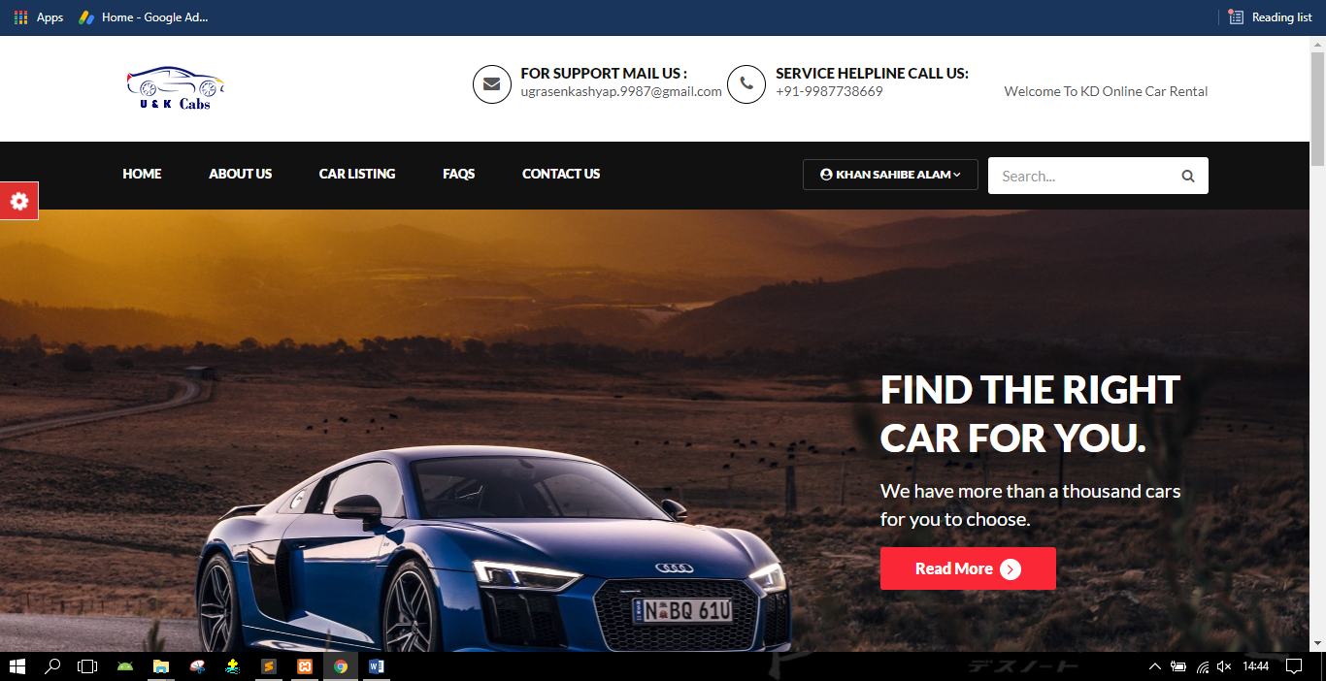

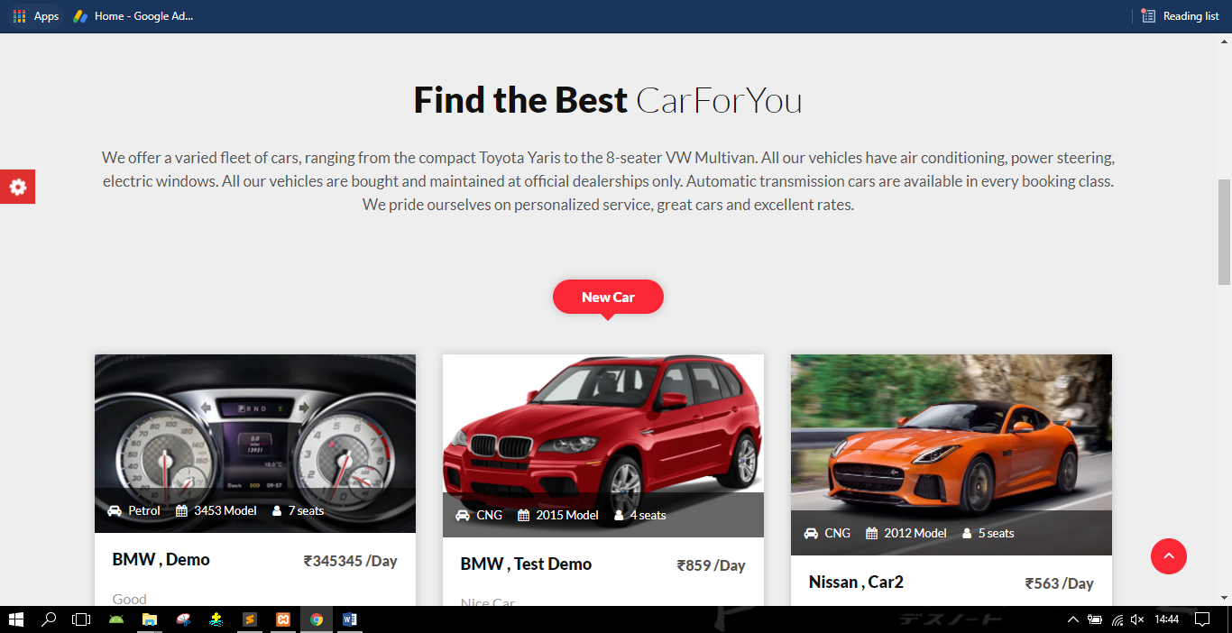

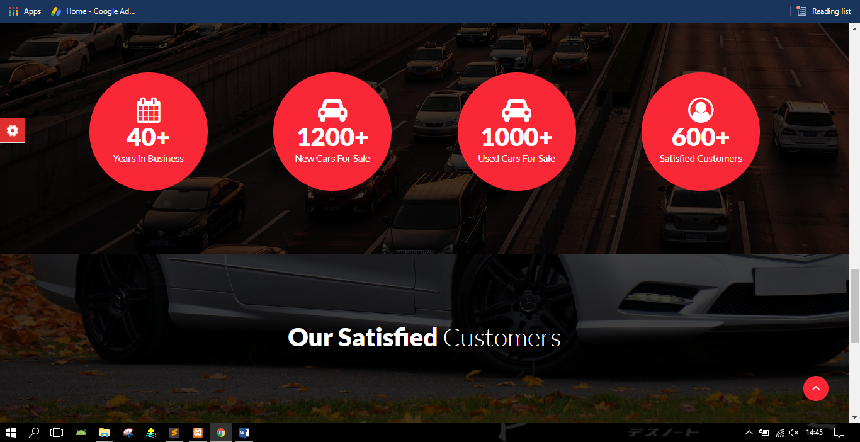

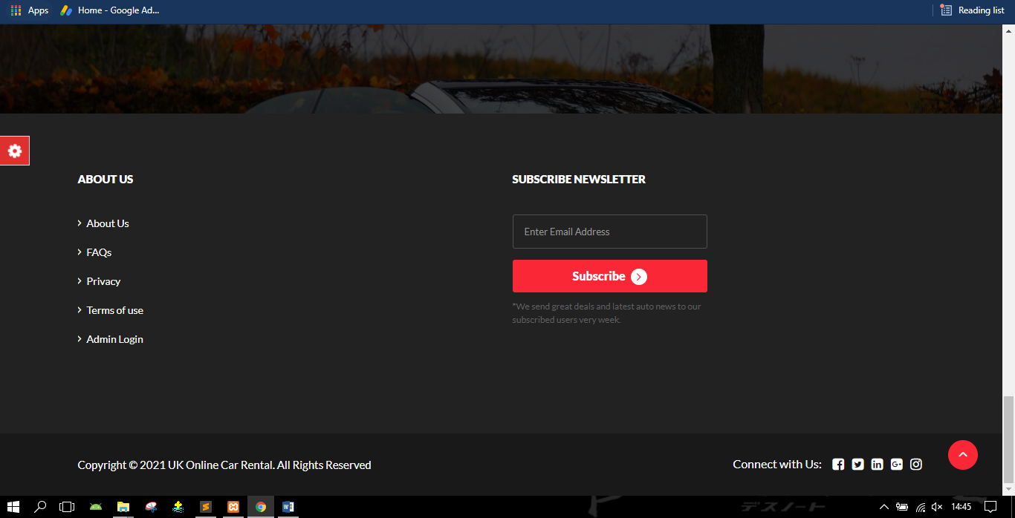

**Login Page**

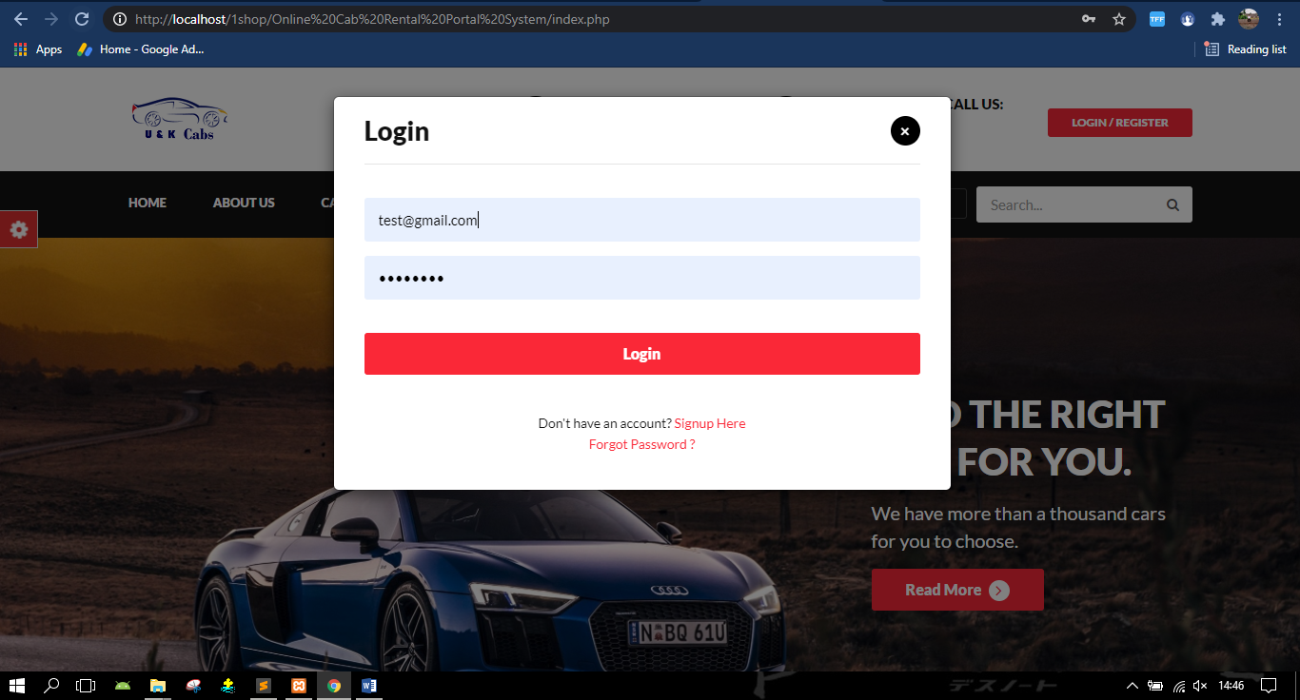

**Car Listing**

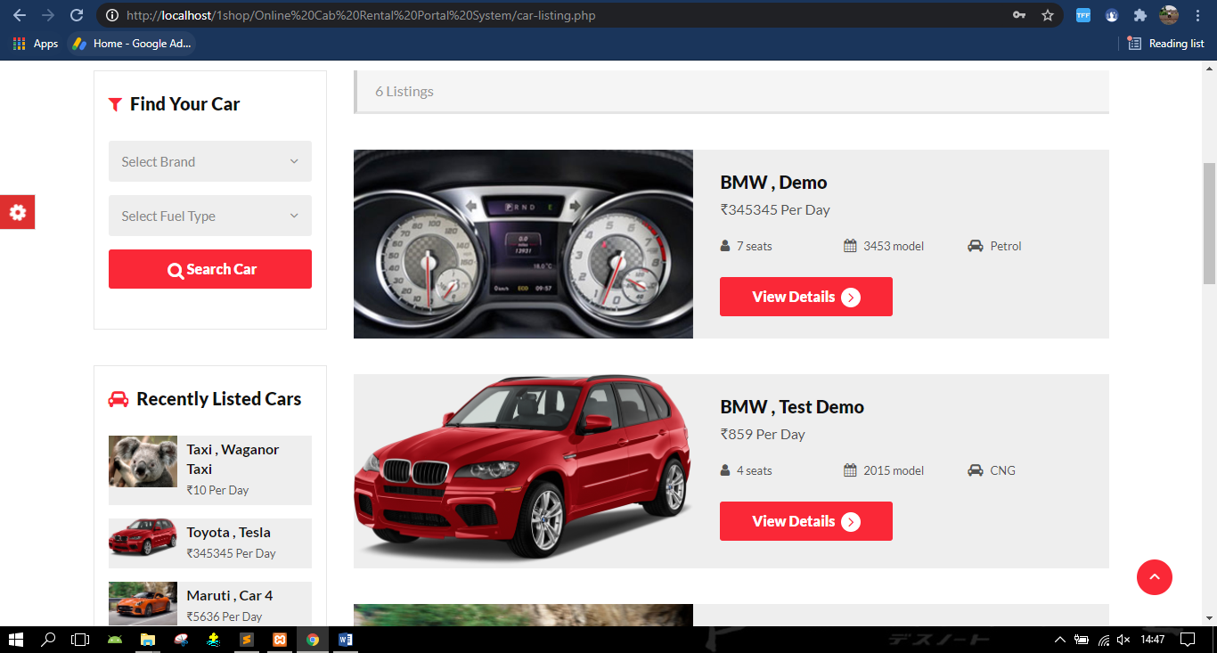

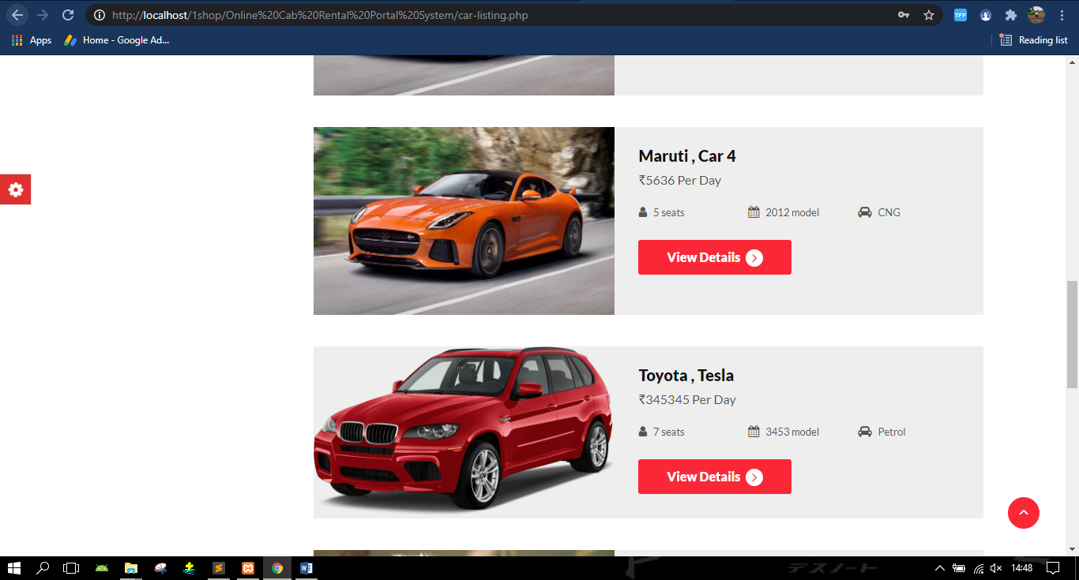

**Book A Car**

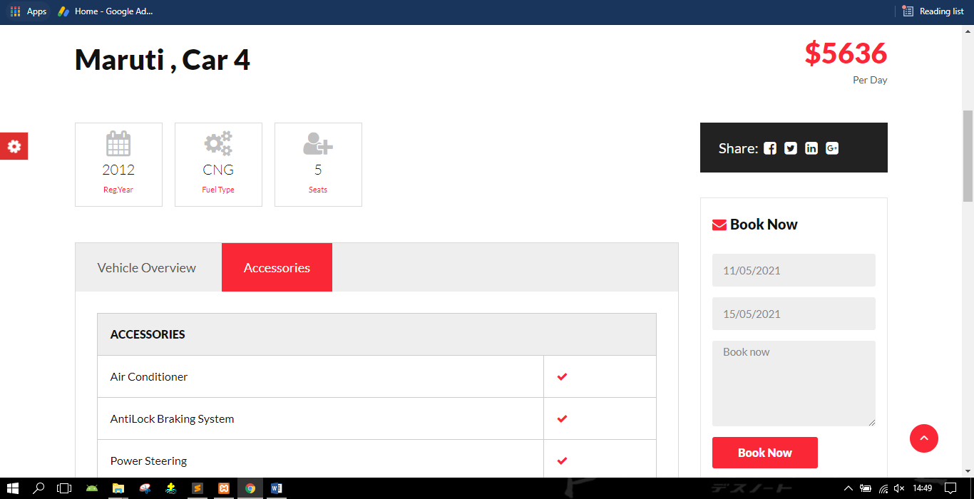

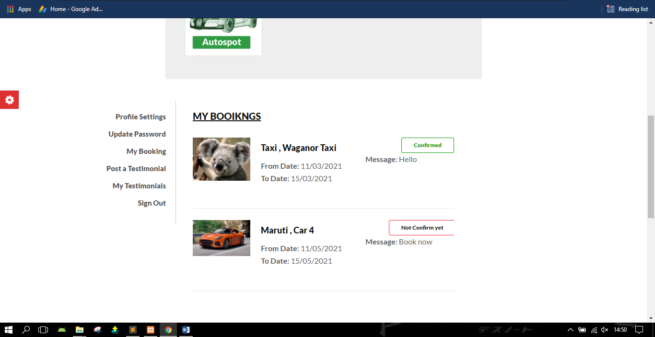

**Profile Setting**

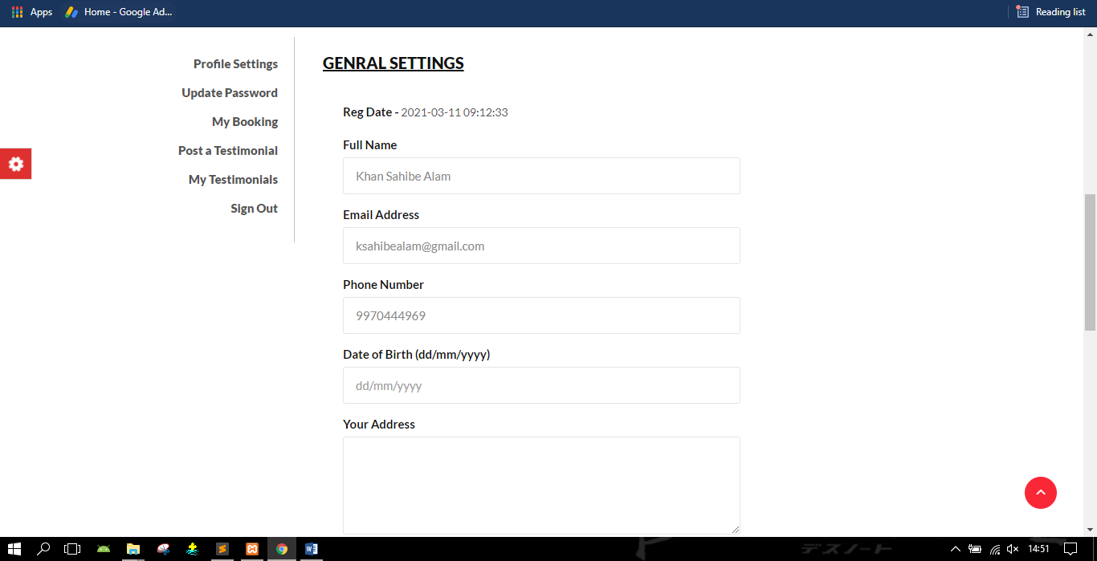

**Update Password**

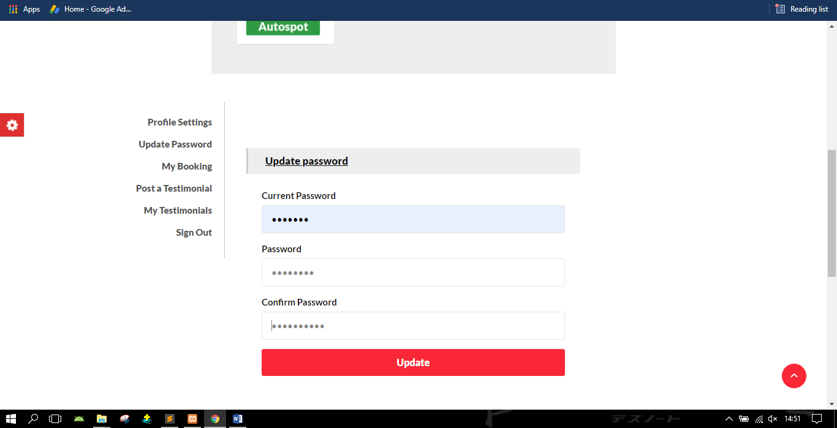

**Post a Testimonial**

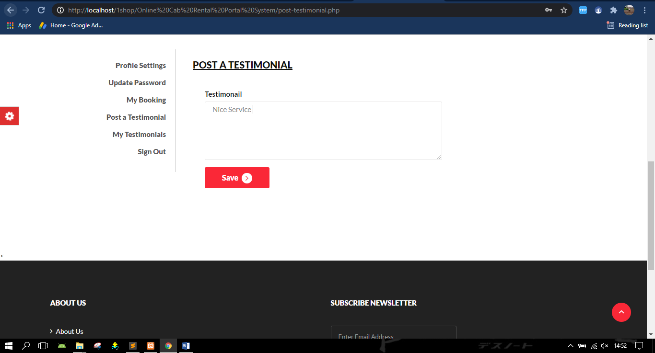

**View Testimonial**

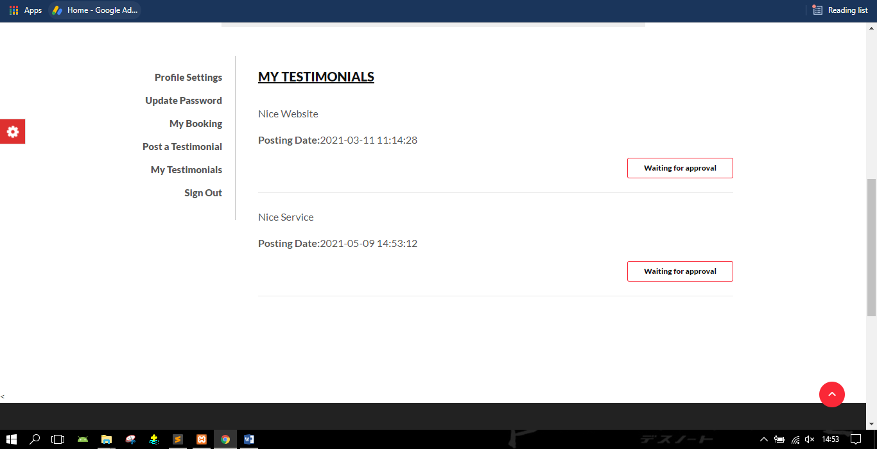

**Admin Login**

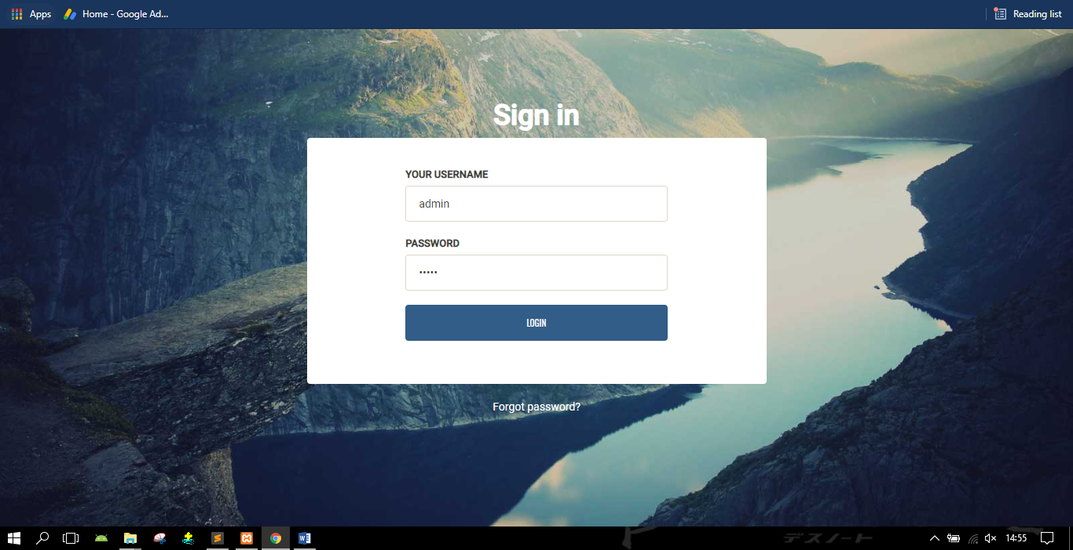

**Admin Dashboard**

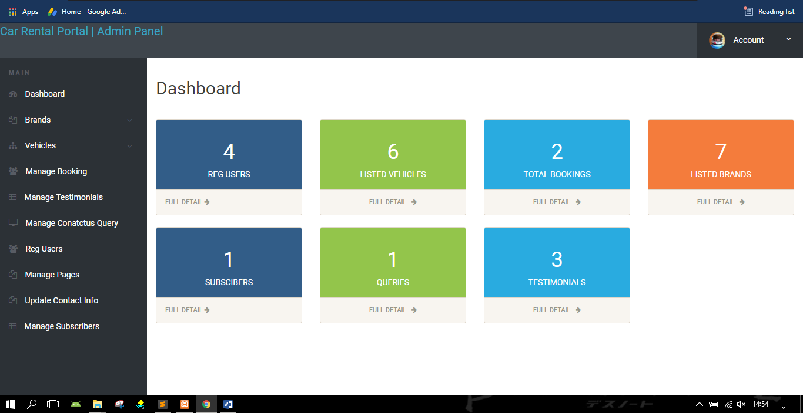

**Create Brand**

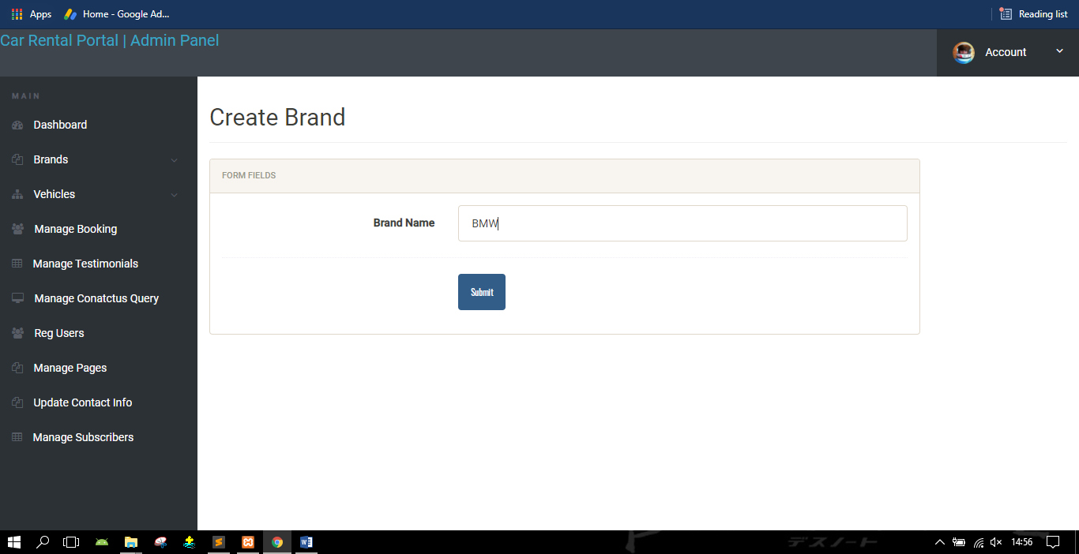

**Manage Brand:-**

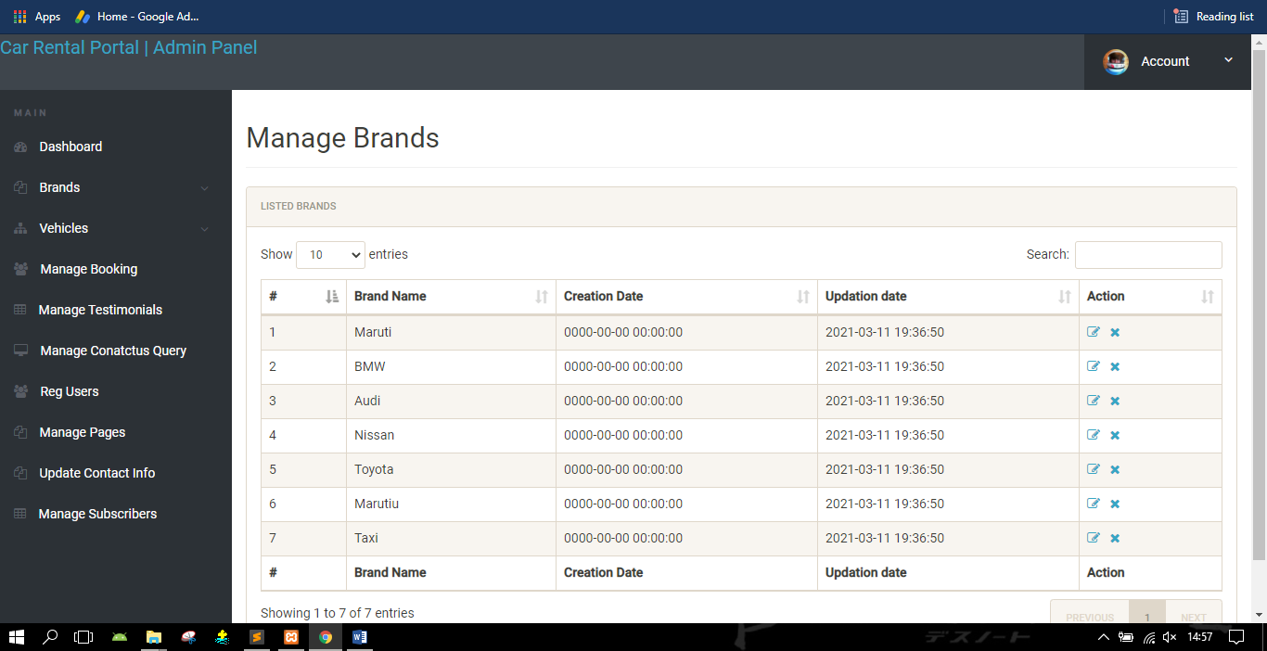

**Manage Booking:-**

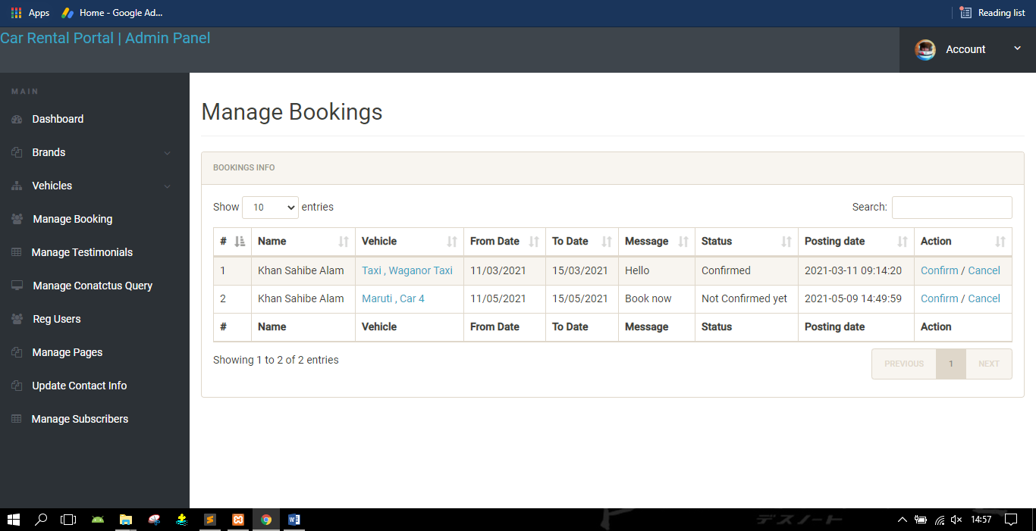

**Manage Testimonials:-**

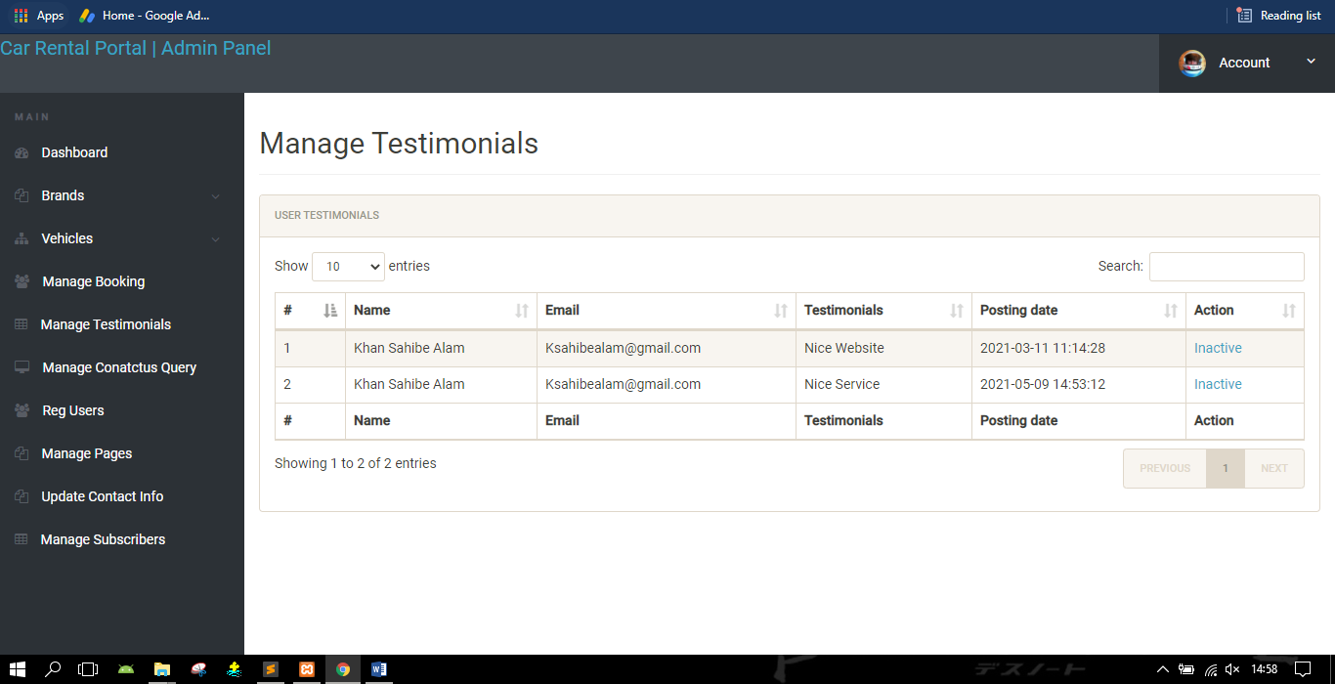

**Manage Contact us:-**

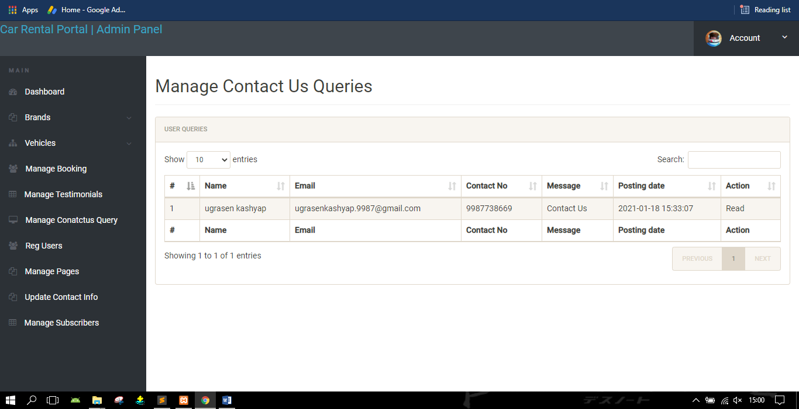

**Registered Users:-**

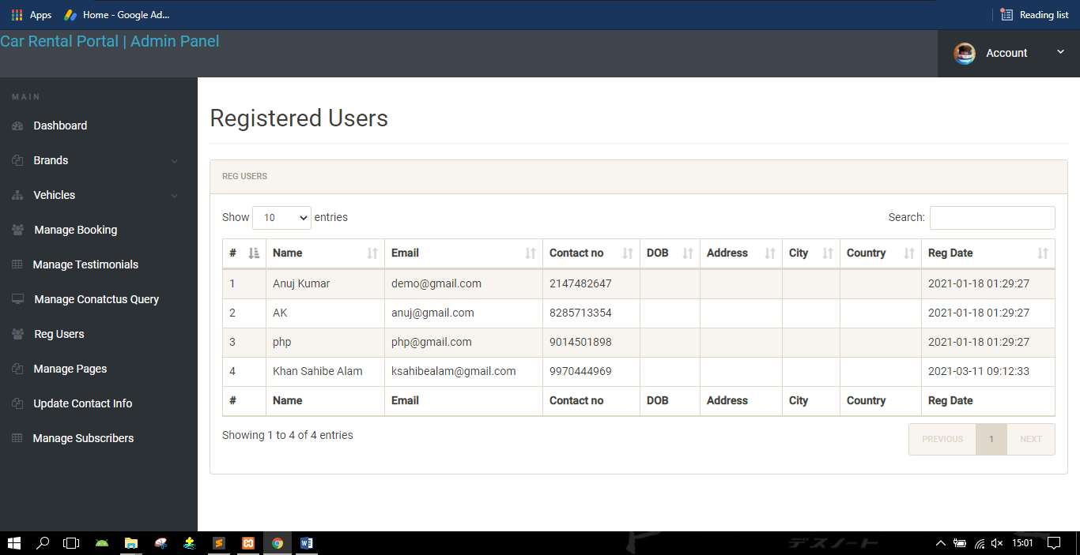

**Manage Pages:-**

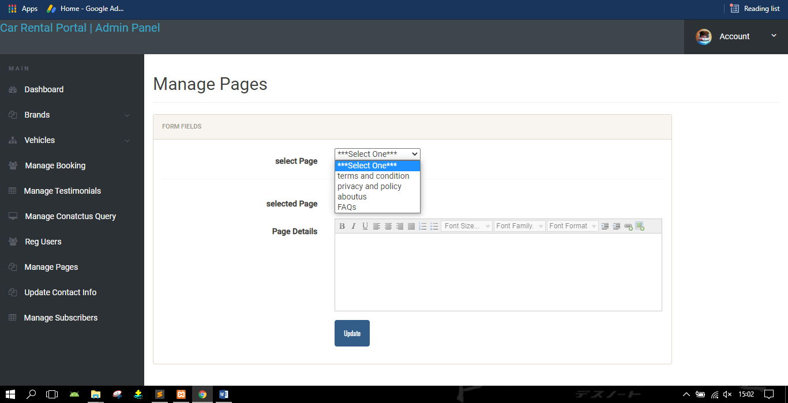

**Update Contact Info:-**

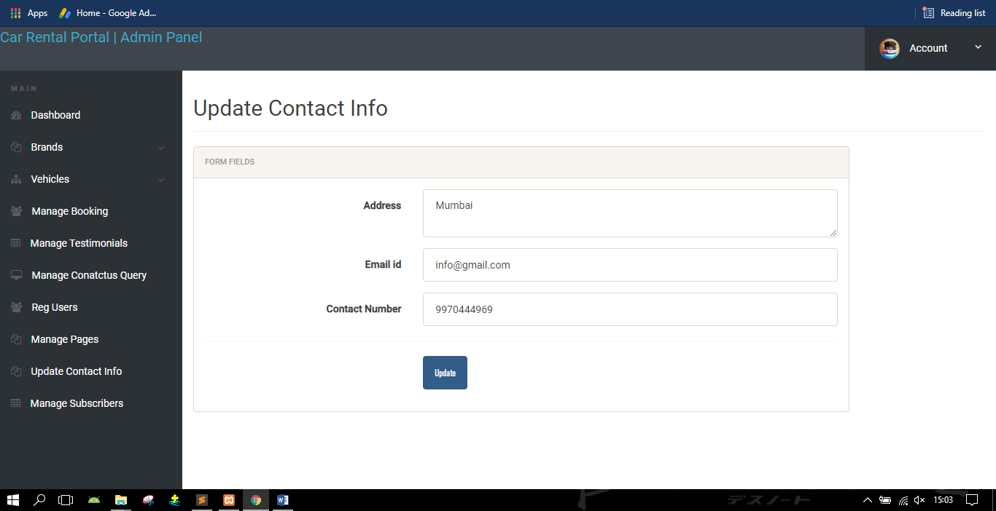

**Manage Subscribers:-**

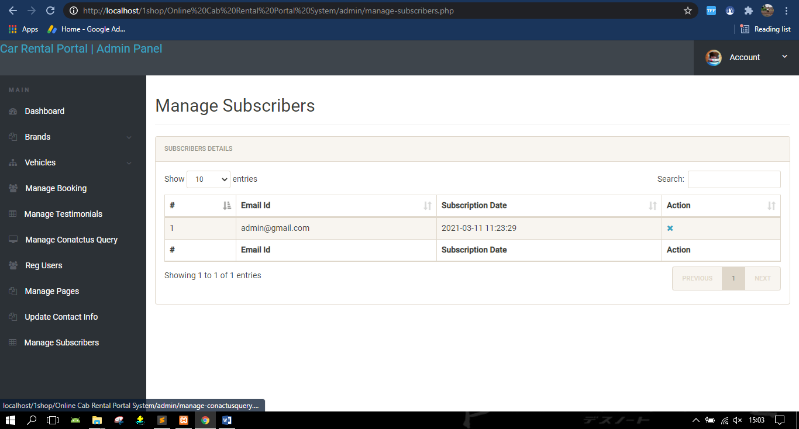

**Confirm Booking:-**

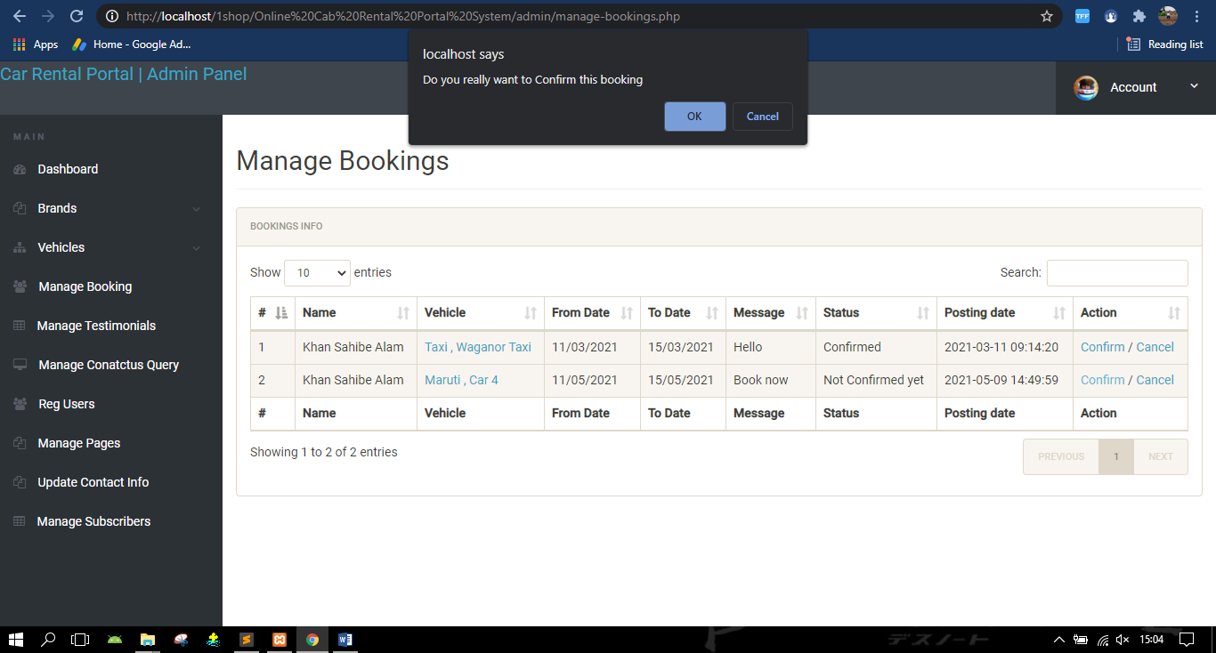

**Confirmation on User Side:-**

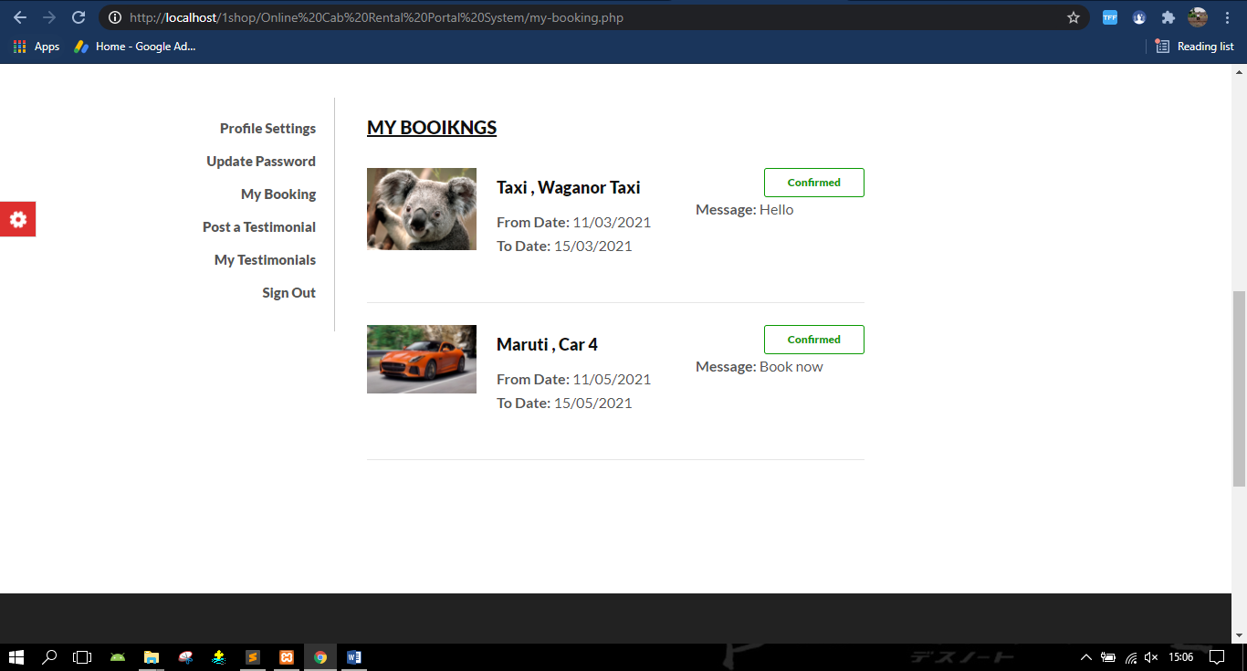

**Admin Change Password:-**

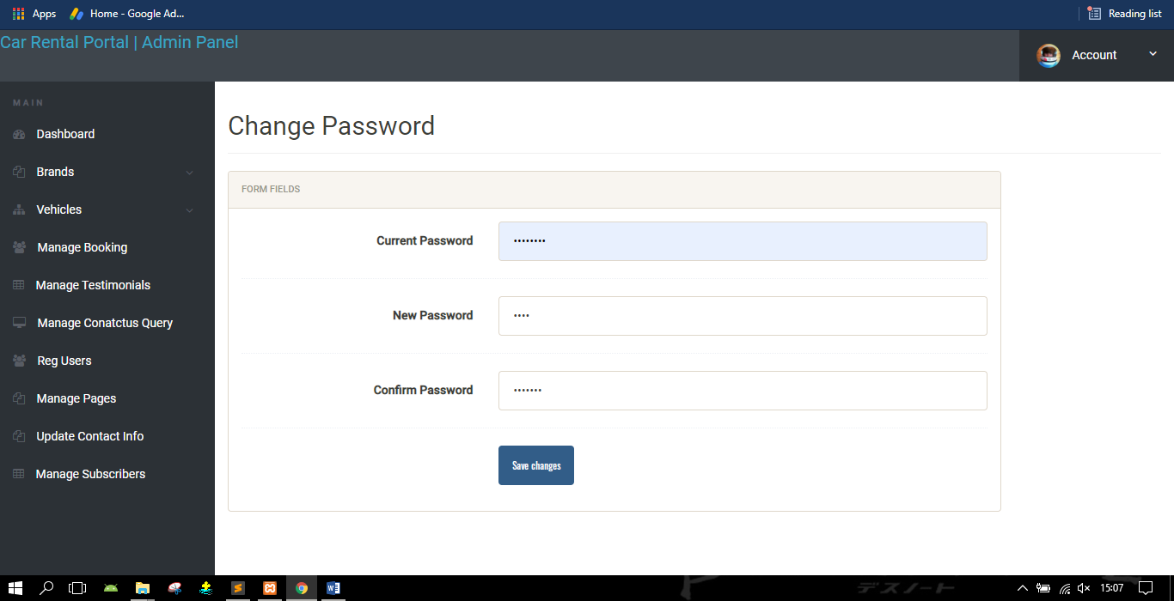

**Chapter 6**

**Conclusion and Future Work**

**Chapter 6: Conclusion and Future Work**

Car rental business has emerged with a new goodies compared to the past experience where every activity concerning car rental business is limited to a physical location only. Even though the physical location has not been totally eradicated; the nature of functions and how these functions are achieved has been reshaped by the power of internet. Nowadays, customers can reserve cars online, rent car online, and have the car brought to their door step once the customer is a registered member or go to the office to pick the car.

The web based car booking system has offered an advantage to both customers as well as Car Rental Company to efficiently and effectively manage the business and satisfies customers’ need at the click of a button.

The primary features of Simple CMS are:

1. Easily editable content, templates (default/auto) ,
2. User authentication, and workflow management.
3. The administration Interface is relatively simple. It features one navigation bar that has different tabs for
4. Respective functions, such as Manage Pages, Manage Users, Manage Style sheets, Configure
5. Homepage and Audit trial report. It has a workflow which will only allow the publishing of
6. The new content when it is approved by the administrator. It has defined users and roles for
7. Users to add, delete or update content within the website. Each user can modify data
8. According to his access rights. Only admin can assign roles to users and has full control over
9. Each user and his activity.

The user can easily integrate a new template, which is basically the HTML and CSS files, into this application. Once it is integrated, the user can easily format and edit the page content using the rich text editor without having to deal with the HTML or the CSS code. Thus this project will be useful to the users with less technical expertise, allowing them to easily manage the content of their page.

**Future Work**

* The System can be enhanced further by make it a web application so as to make the system more user friendly and more convenient so that the people can use the system anywhere from distant places.
* The system can be further enhanced by introducing messaging and email facility so as to send messages to the customers about their order status and even the information about the new services and the packages coming in.
* The customer photo can be uploaded and will be recognized by photo through photo.
* Security will be provided with the hacking

**Chapter 7**

**References**

**Chapter 7: References**

The sources and references used for our project

1. *Website-* [www.w3schools.com](http://www.w3schools.com)
2. *Website-* <https://stackoverflow.com/>
3. *Website-* <https://www.tutorialspoint.com/>
4. *Website-* <https://www.studytonight.com/php/>
5. *Website-* <https://www.php.net/docs.php>
6. The Complete Reference HML (Reference Book)

.